**VIETNAM NATIONAL UNIVERSITY HO CHI MINH CITY**

**UNIVERSITY OF INFORMATION TECHNOLOGY**

**ADVANCED PROGRAM IN INFORMATION SYSTEMS**

**NGUYEN HOANG DUY**

**BUI DUC MANH**

**THESIS**

**BUILDING HUMAN RESOURCE MANAGEMENT SYSTEMS FOR REAL ESTATE COMPANY**

**BACHELOR OF ENGINEERING IN INFORMATION SYSTEMS**

**HO CHI MINH CITY, 2023**

**VIETNAM NATIONAL UNIVERSITY HO CHI MINH CITY**

**UNIVERSITY OF INFORMATION TECHNOLOGY**

**ADVANCED PROGRAM IN INFORMATION SYSTEMS**

**NGUYEN HOANG DUY – 19521425**

**BUI DUC MANH - 19521822**

**THESIS**

**BUILDING HUMAN RESOURCE MANAGEMENT SYSTEMS FOR REAL ESTATE COMPANY**

**BACHELOR OF ENGINEERING IN INFORMATION SYSTEMS**

**THESIS ADVISOR**

**DR. CAO THI NHAN**

**MS. NGUYEN THI KIM PHUNG**

**HO CHI MINH CITY, 2023**

# **ACKNOWLEDGEMENT**

First of all, we would like to express their sincere thanks to all the teachers University of Information Technology - Vietnam National University, Ho Chi Minh City and teachers of Faculty of Information Systems has helped us to have the basic knowledge as a basis for implementation show this thesis.

In particular, we would like to express their deepest gratitude and gratitude to Dr. Cao Thi Nhan who directly guided, repaired and contributed many valuable comments to help the team. We have successfully completed his subject report.

During months of implementing the project, we have applied the knowledge background knowledge that has been accumulated and combined with the study and study of new consciousness. Since then, the authors' team made the most of what they have collected to complete the best project report. However, during the implementation process, we did not avoid shortcomings. Therefore, my team is looking forward to receiving contributions ideas from the teachers to perfect the knowledge that we have learned and is luggage for the group of us to carry out other topics in the future.

Thank you very much, teachers!

**TABLE OF CONTENTS**

ACKNOWLEDGEMENT I

LIST OF FIGURES IV

LIST OF TABLES VI

LIST OF ACRONYMS VII

ABSTRACT VIII

CHAPTER 1: INTRODUCTION 1

1.1 Human Resource Management System 1

1.2. Objectives And Tasks 2

1.2.1. Overall objectives 2

1.2.2. Detail goal 2

1.2.3. Research content 3

1.3. Subjects And Scope Of Research 3

1.3.1. Research object of the project 3

1.3.2. Research scope of the topic 4

1.4. Expected results. 4

1.5. Method of implementing application 4

1.6. Research Timelines 6

CHAPTER 2: LITERATURE REVIEW 7

2.1. General Introduction 7

2.1.1. Basic information about the company 7

2.1.2. Main business and operations of the enterprise 9

2.2. Organizational structure 10

2.3. Current systems of businesses 10

2.4. Related works. 13

2.5. Advantages and disadvantages of software 17

2.6. Why can businesses use our system? 18

2.7. System Survey 19

2.7.1. Description of the problem 19

CHAPTER 3: ANALYSIS AND DESIGN 20

3.1. System Requirements Specification 20

3.1.1. Identify the system. 20

3.1.2. Entry requirements 21

3.2. System Analysis and Design 24

3.2.1. Determine requirements. 24

3.3.2. Use Case Diagram 29

3.3.3. Sequence Diagram 31

3.3.4. Class Diagram 36

3.3.5. State Diagram 36

3.3.6. Database design 40

CHAPTER 4: IMPLEMENTATION RESULTS 49

4.1. System development technologies 49

4.2. System functions - Software functions: 49

4.3. Steps to be followed in order for employees. 67

4.3.1. Steps For ADMIN: 67

4.3.2. Steps For STAFF:​ 67

CHAPTER 5: CONCLUSION 69

LIST OF REFERENCES 70

APPENDIX: SURVEYS FORM OF REAL ESTATE COMPANY 71

# **LIST OF FIGURES**

Figure 2. 1: Organizational structure of the board of directors 10

Figure 2. 2: Interface of HrOnline software 11

Figure 2. 3: Interface of Perfect HRM 2012 software 12

Figure 2. 4: Personnel management chart of PwC Vietnam company 14

Figure 2. 5: information of employee 16

Figure 2. 6: Some basic information 17

Figure 3. 1: Timesheet for interns 22

Figure 3. 2: Timesheet for employee 23

Figure 3. 3: Timesheet for management 23

Figure 3. 4: List of awarded/ disciplined employees 24

Figure 3. 5: Employee management function 25

Figure 3. 6: Department management function 25

Figure 3. 7: Company management parameters 26

Figure 3. 8: Use case system. 29

Figure 3. 9: Use case diagram Employee management. 30

Figure 3. 10: Login Sequence Diagram 31

Figure 3. 11: Search Sequence Diagram 32

Figure 3. 12: Insert sequence diagram 33

Figure 3. 13: Update sequence diagram 34

Figure 3. 14: Delete sequence diagram. 35

Figure 3. 15: Class Diagram 36

Figure 3. 16: State diagram of class “Employee Profile” 36

Figure 3. 17: Search Diagram 37

Figure 3. 18: Reward – Discipline Diagram 38

Figure 3. 19: Insurance Diagram 39

Figure 3. 20: Human resource management software data relations. 40

Figure 3. 21: Login Process. 44

Figure 3. 22: Search Process 45

Figure 3. 23:Updated Process 46

Figure 3. 24: Report Printing Process 47

Figure 3. 25: Insert information diagram. 48

Figure 4. 1: Login interface 54

Figure 4. 2: Employee list management screen. 55

Figure 4. 3: Employees by department 55

Figure 4. 4: Email messages interface 56

Figure 4. 5: Email messages result 56

Figure 4. 6: Department management screen. 57

Figure 4. 7: Salary management screen. 58

Figure 4. 8: Change payroll screen 58

Figure 4. 9: General salary schedule 59

Figure 4. 10: Reward / Discipline management screen. 59

Figure 4. 11: Timekeeping management screen 60

Figure 4. 12: Project management screen 61

Figure 4. 13: Employee assigned project screen 61

Figure 4. 14: Application for leave screen 62

Figure 4. 15: Statistical users screen 62

Figure 4. 16: Company salary statistics in 2023 63

Figure 4. 17: Dismissal employee interface. 63

Figure 4. 18: Export report to excel screen 64

Figure 4. 19: Result of excel screen. 65

Figure 4. 20: Login user screen. 66

Figure 4. 21: Information user screen. 66

Figure 4. 22: Information salary user screen. 67

Figure 4. 23: Personal timesheet screen. 68

Figure 4. 24: Timekeeping screen 68

Figure 4. 25: Annual leave function for user 69

Figure 4. 26: Project of employees 70

Figure 1: Employee survey form 71

Figure 2: The survey form has been filled out. 72

# **LIST OF TABLES**

Table 3. 1: Store employee information 41

Table 3. 2: Store employee position information. 41

Table 3. 3: Store department information. 41

Table 3. 4: Store employee timekeeping information. 42

Table 3. 5: Store employee evaluation information. 42

Table 3. 6: Store employee reward and discipline information. 42

Table 3. 7: Store employee on leave information. 43

Table 3. 8: Store employee leave information. 43

Table 3. 9: Store employee leave information. 43

Table 3. 10: Store employee shift information. 44

# **LIST OF ACRONYMS**

1. DFD: Data flow diagram

2. ORMs: Object-Relational Mapping

3. GUI: Graphical user interface

4. BLL: Business Logic Layer

5. DAL: Data Access Layer

6. BUS: Business Layer

7. WPF: Windows Presentation Foundation

8. PwC: PricewaterhouseCoopers

# **ABSTRACT**

Society is developing more and more strongly, along with the increase in more and more businesses; specifically in our country the number of businesses is quite large and increasing day by day. Currently, the application of information technology in production and business has brought enormous benefits to businesses. In order for businesses to operate and develop in today's times, the application of "information technology" in business management is really necessary. Informatics will be a powerful right hand of administrators, it helps optimize time, resources and costs. Seeing the importance of information technology, more and more software companies in Vietnam are being formed and developed, building systems and improving product quality to keep up with technology trends. world. In addition, businesses also strive to invest and develop their own software to best serve business purposes and achieve high efficiency. To have good and useful management systems, we must have quality human resources. People who are always researching and constantly striving to learn, develop and create.

University students, especially those majoring in information technology and management information systems, are the main human resource contributing to bringing the country's science and technology further and further into the new era. As a final year student majoring in Information Systems - To successfully complete my graduation thesis and to learn and improve knowledge and skills for future work. I would like to choose Hung Thinh Real Estate Company as the place to develop and complete this graduation thesis.

# **CHAPTER 1: INTRODUCTION**

## 1.1 Human Resource Management System

Vietnam is entering a new millennium, an era of science and technology, an era of information. Along with the rapid development of today's society, information is considered an extremely important resource for every business organization. Good operational planning as well as effective management through correct decisions must rely on regularly updated and high-quality information sources.

With such information requirements, there arises a need for leaders and managers to change the way of working and receive a new member of the information management and processing team - that is, Information system – information and data management system based on computers. Information systems are an important means to provide necessary information for any operating organization.

Thus, building an information system that helps automate management work is an essential need of every business. Application of information systems in management has become popular in our country. Many organizations and businesses have applied information systems to various tasks such as: managing incoming and outgoing dispatches; document and record management; financial management - accounting; workforce management; customer management; Asset Management...

In particular, the human resource management information system is of interest and attention to all businesses of all economic sectors. An enterprise's human resource management information system is a system that comprehensively reflects the mental and physical potential of each employee, including quantity and quality at all times: past, present. now and expected in the future. Therefore, human resource management must be carried out regularly, providing timely and complete information as requested by upper management in order to successfully complete the company's plans and tasks in each period.

## 1.2. Objectives And Tasks

### **1.2.1. Overall objectives**

The topic "Analysis and design of human resource management information system for Real Estate Group" is proposed to businesses with the goal of surveying and evaluating the status of human resource management at the company **[1].** In reference to similar management systems, the company that we refer to and have researched on in many aspects is the real estate Hung Thinh group **[6].** From there, we propose a solution to analyze and design a suitable human resource management information system, solving the company's human resource management problem, helping the company achieve high efficiency in record management and management, working process and labor contracts of employees **[5].**

### **1.2.2. Detail goal**

Conduct a survey of the company's leadership and staff on the need to build a human resources management information system. Collect at least 20 survey results, and through the results, evaluate the status of the company's human resource management (limitations, difficulties, level of job completion according to human resource management). the current needs of the company's board of directors and employees regarding human resource management in the future).

Conduct analysis and design of the company's human resource management information system according to the object-oriented method and use the general modeling language of the object-oriented system - UML. The analyzed and designed information system must fully meet the company's human resource management operations and be easy to use, upgrade and maintain.

After analyzing the design, it must help users visualize the system through results including:

- Overview description of the system (main functions, function descriptions, function implementers...).

- Complete the diagrams: UC, class, state, activity, component, deployment.

- Design database relationship diagrams and system interfaces. Make suggestions so the company can continue to improve the project.

### **1.2.3. Research content**

Research proposal: Research proposal topic "Building human resource management system for Hung Thinh real estate group". This product presented in this graduation thesis will be built according to the direction object-oriented methods and use of modeling languages.

Research content:

* Learn about the organization and operations of Hung Thinh Real Estate Group and some other companies such as: PwC (PricewaterhouseCoopers Vietnam), Kytesoft Technology, …
* Learn about the company's such as salary calculation, timekeeping, social insurance management, maternity leave for employees, overtime, and allowances for employees. With these skills, we can build complete software.
* It is necessary to study the needs of the business that may arise in the future to find a suitable and highly flexible software design solution to meet any changes that may arise. What could happen?

## 1.3. Subjects And Scope Of Research

### **1.3.1. Research object of the project**

Conduct a survey of the management and employees in the company about the need to build a human resource management information system by creating a form to survey opinions, evaluations and related comments to get ideas to build the most basic and structured system. Collect at least 20 survey results, through the results, it is necessary to evaluate the current situation of human resource management of the company (limitations, difficulties, level of job completion according to human resource management).

### **1.3.2. Research scope of the topic**

The application was built with the purpose of serving employee profile management, salary management, timekeeping, as well as employee rotation tasks, insurance management, and benefits. Therefore, its users are competent employees of the business, more specifically, business leaders and employees of the company's human resources department.

## 1.4. Expected results.

Build complete software for practical applications in company

The software runs on all operating systems, does not require high configuration.

The software operates stably after 2-4 weeks from the date of deployment without affecting the organizational structure.

The system meets the need to automate human resource management work

Build complete software for practical applications with professional functions:

* Management function: Allows managing and updating employee information.
* Update qualifications, employee documents, salaries, bonuses, and discipline.
* Provide statistical reports on: Timekeeping reports, salary reports.

The software allows multi-user data access, each part can access data simultaneously

The software has fast data entry and retrieval speed, and searches by many different topics

The software is designed with an intuitive, user-friendly interface

Allows automation of periodic tasks that do not change frequently.

## 1.5. Method of implementing application

In this thesis, we use a 3-layer model (3 layers). -tier architecture) is a software development architecture used to separate and organize application source code into three main layers or parts, each with specific goals and responsibilities, and to limit risks and ease Easy to use and maintain the system. These classes include:

+ Presentation Layer: This is the first layer that users interact with and displays information to them. The Interface layer manages the user interface (UI), including windows, forms, web pages, or mobile applications. It is responsible for collecting information from users and transmitting it to the Business Logic Layer.

+ Business Logic Layer: This layer contains the business logic of the application. It handles requests from the Interface Layer and performs tasks such as data processing, calculations, business rules, and sending and receiving data from the Data Access Layer. The Business Logic layer ensures that data is processed according to predefined business rules.

+ Data Access Layer: This layer works with the database to perform query and update operations. It is responsible for connecting to the database, executing SQL queries or using ORMs (Object-Relational Mapping) to interact with data. The Data Access Layer provides a uniform interface to the Business Logic Layer to interact with the database without needing to know the details of the database.

The benefits of the 3-layer model:

* Division into classes makes the code more explicit. Thanks to dividing each layer to take on different and separate functions such as interface, processing, query instead of leaving it all in one place. To reduce adhesion.
* Easy to maintain when divided, a system component will be easy to change. This change can be isolated into 1 class or affect the nearest class without affecting the whole program.
* Easy to develop and reuse when we want to add a certain function, programming according to a model will be easier because we already have a standard to follow just change the GUI layer again.
* Easy to hand over. If everyone follows a predetermined standard, handover work and interaction with each other will be easier and save a lot of time.
* Easy to distribute workload. Each group and department will receive a task in the 3-layer model. Such a clear division will help programmers control their workload.

## 1.6. Research Timelines

Research timelines: From 01/09/2023 to 31/12/2013:

September:

+ Week 1-4: Research papers and surveys related to the issue of creating responsive software that influences, analyzes and identifies key user-related factors.

October

+ Week 1-2: Collect user metrics from available data and deploy data analytics.

+ Week 3-4: Process and analyze collected data.

November:

+ Week 1-2: After completing data analysis and processing, pour the data into the web/app to test the system.

+ Week 3-4: Proceed to build a web/app according to the data model and previously collected research.

December:

+ Week 1-2: Develop a complete web/application system and test and refine the system based on users.

+ Week 3-4: Write a report.

# **CHAPTER 2: LITERATURE REVIEW**

## 2.1. General Introduction

### **2.1.1. Basic information about the company**

**\* Basic information about Hung Thinh Group:**

- HUNG THINH Group has more than 20 years of establishment and development with more than 59 projects and more than 3,300 hectares of land fund, providing more than 30,000 products to the market. Projects invested and developed by HUNG THINH GROUP are spread across the country, not only stopping in key cities such as Ho Chi Minh City but also expanding in potential areas such as Binh Duong and Dong Nai., Ba Ria - Vung Tau, Binh Thuan, Lam Dong, Khanh Hoa, Binh Dinh and Hanoi.

- With the core being real estate, Hung Thinh officially transformed into a Group model, innovating and building a complete ecosystem including: investment and development of all types of real estate, construction, PropTech and Fintech technology, business on digital platforms...

- This new model with a resonant philosophy to increase value in a comprehensive ecosystem will help HUNG THINH Group enhance its adaptation and elevate its leading position in the Vietnamese real estate market. Inheriting more than 20 years of experience, member companies in the new ecosystem will maximize their capabilities to create more products with real value, bringing trust, satisfaction and many benefits. Practical benefits for Customers and Partners when participating in the ecological chain to develop together "For a prosperous community".

- Not only focusing on business development, HUNG THINH GROUP also actively participates in community activities - one of the good traditions that the Group always values. With reputation built in the market and trust in customers, Hung Thinh has been honored to receive more than 200 noble titles: Typically, TOP 10 VIETNAMESE GOLD STARS 2021, EXCELLENT VIETNAMESE ENTERPRISES IN ASIA 2020 - 2021, Ho Chi Minh City Gold Brand 2021, TOP 10 PRESTIGIOUS REAL ESTATE INVESTORS 2019 - 2020, ....

**\* Company information:**

- International name: HUNG THINH GROUP CORPORATION

- Vietnamese name: CÔNG TY CỔ PHẦN TẬP ĐOÀN HƯNG THỊNH

- Business code: 0305410561 - District 3 Tax Department issued on December 6, 2007

- Head office: 191 Nam Ky Khoi Nghia, Vo Thi Sau Ward, District 3, Ho Chi Minh City

- Phone: (028) 7307 5888

- Email: info@hungthinhcorp.com.vn

- Website: https://www.hungthinhcorp.com.vn/

- Representative office in Hanoi: VCCI Building, No. 9 Dao Duy Anh, Dong Da District, Hanoi City

- Phone: (024) 7307 6879

- Legal representative: Nguyen Dinh Trung

**\* Some typical projects and investments:**

**- GOLDEN BAY** (Investor project): Located next to the resort complex in the Northern Cam Ranh Peninsula International Tourism Area (Khanh Hoa province), Golden Bay is the first urban area here. The project is 79 hectares wide, including 8 sub-areas with architectural characteristics of developed countries such as Russia, America, France, Italy, Australia, Spain, Korea and Japan. With high-end amenities such as 4-star hotels, shopping centers, sports centers, schools, parks... and a prime location (near Cam Ranh International Airport), Golden Bay will bring a perfect life for the residents here.

Project Information:

Location: Lot D16 - D17, Area 5 - Northern Cam Ranh Peninsula tourist area, Khanh Hoa province Total area: 79ha Investor: Hung Thinh Group Joint Stock Company Design consultant: Company Archipel Joint Stock Company (France) Design leader: Architect Christophe Jean Louis Total investment: 4,500 billion VND

- **HIGH-LEVEL HOTEL - COMMERCIAL SERVICES - ENTERTAINMENT AND URBAN COMPLEX** (Investor project): The project is in the Northern Cam Ranh Peninsula tourist area. Including items: International entertainment center, resort hotel, urban and commercial area with world-class entertainment services, fully meeting the needs of area residents and tourists...

Project Information:

Location: Area 5 - Northern Cam Ranh Peninsula tourist area, Khanh Hoa province Total area: 387.5 hectares Investor: Hung Thinh Group Joint Stock Company Design consultant: Architecture Joint Stock Company Prowind Design leader: Architect Christophe Jean Louis Total investment: 3,740 billion VND

- **8X DAM SEN APARTMENT** (Project development): 8X Dam Sen is located on the front of To Hieu street - the administrative center of Tan Phu district. In particular, the project is located near Dam Sen cultural park - one of the largest entertainment areas in Saigon, loved by many domestic and foreign tourists. The airy space, smart design and modern equipment at 8X Dam Sen will become the pride of the young owners here. The apartment was completed and handed over to customers in August 2016.

Project Information:

Location: 57 To Hieu, Hiep Tan Ward, Tan Phu District, Ho Chi Minh City Total area: 6,188.5m2 Total number of apartments: 594 apartments Project development: Hung Thinh Group Joint Stock Company Total investment: 630 billion VND.

And there are many projects in all provinces and cities.

### **2.1.2. Main business and operations of the enterprise**

* Investment and development of all types of real estate **[8]**
* Construction
* PropTech and FinTech technology
* Doing business on digital platforms
* Innovation and technology transfer

## 2.2. Organizational structure

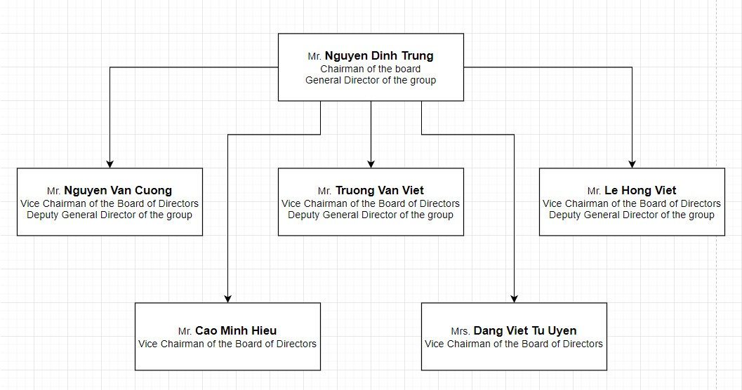

*Figure 2. 1: Organizational structure of the board of directors*

*(source:* [*https://hungthinhcorp.com.vn/gioi-thieu.html*](https://hungthinhcorp.com.vn/gioi-thieu.html)*)*

## 2.3. Current systems of businesses

Firstly, we chose this topic because we also wanted to try making a software for human resource management to see the challenges and difficulties encountered when making a management software. Secondly, we were very lucky to be able to get data about 50 employees from Hung Thinh company, so we decided to make software to manage employees at Hung Thinh company. Similarities between my group software and other software that we have referenced on websites: My group software also has some basic functions such as:

* Adding, deleting, editing employee information, reward and discipline information, ...
* Provide accounts for employees.
* View payroll and timekeeping for Admin
* Look up employee information.
* Export system reports

**Some related software:**

**HrOnline human resources management software of SoftOne company**:

Highlights of HrOnline software:

- A diverse statistical reporting system helps businesses have the most comprehensive view of the company's personnel situation, employee salaries, and quick statistics on personnel fluctuation indicators during the year.

Highlight’s function:

* Online leave approval feature
* support for shift submission - shift rotation
* easy job and project management
* intuitive reporting system and easy to track.

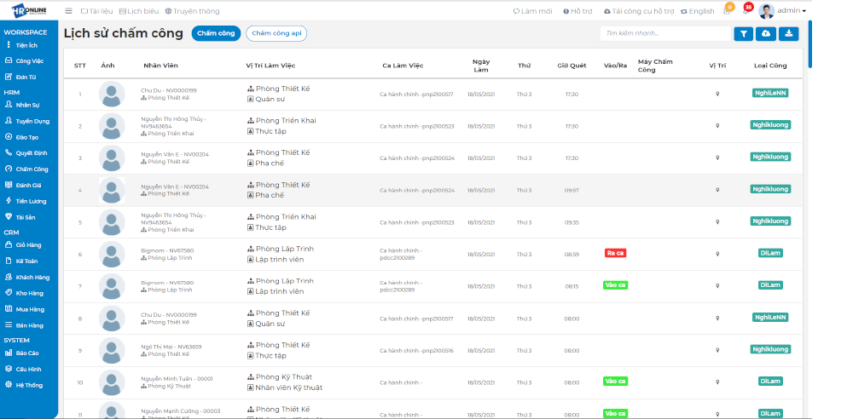

Figure 2. 2: Interface of HrOnline software

**Perfect HRM 2012 human resource management software**:

- For medium businesses with about 100 employees.

- Enterprises synthesize timekeeping and salary data from the 1st to the end of the month.

- Not for businesses that keep track of time and calculate salaries based on sales or products.

Advantage:

* The Vietnamese interface is easy to understand and familiar to domestic companies.
* Easily edit data, create human resource management reports, automatically calculate salaries, benefits, holidays for employees
* Especially good security.

Disadvantage:

* The interface is a bit complicated, it takes some time to get used to.

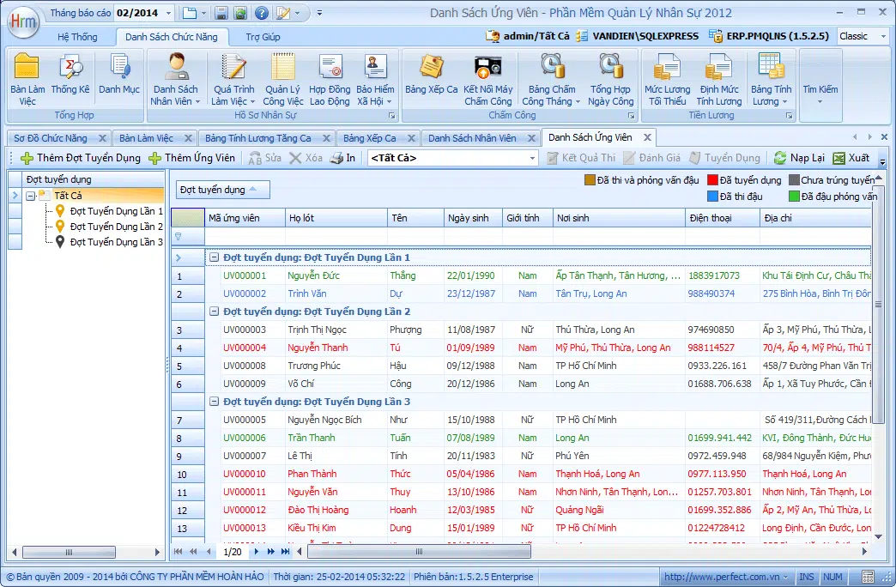

Figure 2. 3: Interface of Perfect HRM 2012 software

Because our project may be for small companies, the functionality will not be as much and perfect as in large companies. Also due to its small scale, our software still has many shortcomings compared to other software we have mentioned such as:

* Automatically update employee holidays
* That employee can submit a leave application into the system from his or her own account, then the Director can view the application and approve the employee's leave date.
* Automatically update salary based on timekeeping list.

Our projects section has some special functions such as:

* Display graphs for easy management control
* Self-timekeeping function for employees using company-issued accounts.

## 2.4. Related works.

**\*** Currently, there are many modern human resource management software used in companies, and the company we have surveyed their technology and human resource management software is PricewaterhouseCoopers LLC (PwC).

- PwC Vietnam is a company specializing in audit, tax, and law. They have Lines of Services (LoS) such as:

- **Audit & Assurance**: Specializing in auditing for clients, financial audit

- **Deal advisory**: Consulting on sales and business strategies

- **Tax & Legal**: Consulting on taxes and making tax-related reports

- **Internal Firm Services (IFS):** Company internal support services include services such as: IT, HR...

Of course, their management software is also divided into branches and follows the diagram from director down to manager and then associates.

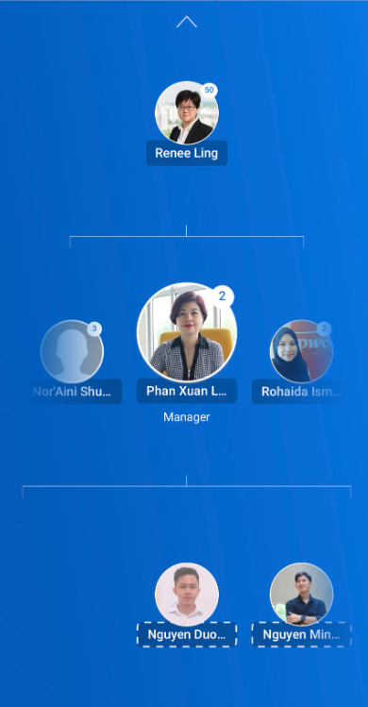

Figure 2. 4: Personnel management chart of PwC Vietnam company

Because PwC company is a global corporation, their human resource management software is very strict and comprehensive. Below are some strengths of PwC's human resources management software:

**+ Comprehensive Human Resources Information Management:**

- Human resource data and information are comprehensively managed and easily accessible.

- Integrate information such as employee profiles, work history, skills and training, work performance, and other related information.

**+ System Integration:**

- Connect and integrate with other systems such as budget accounts, accounting systems, and other applications to optimize workflow.

**+ Performance Management and Personal Development:**

- Provide tools to evaluate and track individual performance as well as propose personal development plans.

- Supports goal setting and performance monitoring.

**+ Attendance and Time Management:**

- Integrate automatic timekeeping and work time tracking.

- Provides features for managing shifts, leaves, and special working modes

**+ Recruitment and Selection Features:**

- Provide tools to manage job ads, manage candidate profiles, and support the recruitment process.

- Integrate technologies such as artificial intelligence to optimize the recruitment process.

**+ Welfare System and Benefits Management:**

- Manage employee benefits and welfare programs.

- Integrate management features for insurance, health, and other programs.

**+ Security and Compliance:**

- Ensure safety and legal compliance with regulations on human resource data management.

- Provides access rights management to protect personnel information.

**+ Compatibility and Expansion Features**:

- Compatible with other systems and applications to meet the needs of large businesses.

- Extensible and customizable support to grow with organizational changes.

**+ Features integrating Artificial Intelligence (AI) and Data Analysis:**

- Use AI to classify and evaluate candidate profiles.

- Analyze data to provide strategic information about human resources.

**Some survey images from PwC Vietnam's human resources management software:**

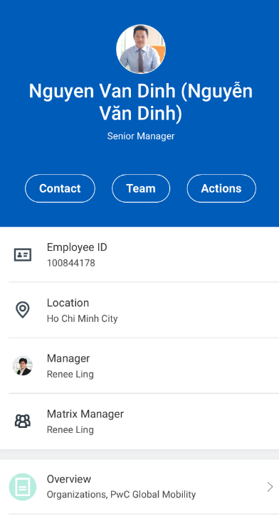

Figure 2. 5: information of employee

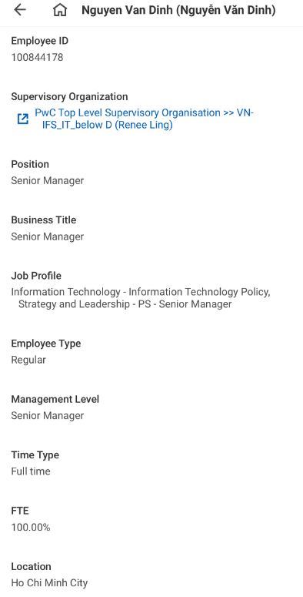

Figure 2. 6: Some basic information

* From the survey of PwC VietNam's human resources management software, it has helped us have the most overview in researching, surveying and implementing a human resources management software suitable for businesses.

## 2.5. Advantages and disadvantages of software

**\* Advantages:**

* **UI**: User-friendly interface
* **Flexibility:** Easy to use for small and medium companies
* **Management:** Clear management functions
* **Security:** Secure personal information of each employee
* **Efficiency:** Increase management efficiency

**\* Limitations:**

* **Statistics:** Statistics are still sketchy.
* **Storage:** Limited storage of personal information
* **Platform:** Technical infrastructure is still low enough to apply to large businesses.
* **Functional limitations:** The system may not meet the special requirements of some businesses, especially those with unique operating models.
* **Integration capabilities:** Some businesses already use different systems such as accounting, project management, and CRM, and integrating HR management software with these systems can be a challenge.

## 2.6. Why can businesses use our system?

To explain why a real estate agent might choose your system, there are some important factors to consider. Here are some points that our system has to convince real estate companies:

* **Ease of Use and Friendly User Interface:** Your system has an easy-to-use user interface, making it convenient for employees and end users to operate and interact with it. This reduces training and transition time from the old system to the new system.
* **High Performance and Stability**: If your system has high performance and stability, real estate companies can rely on it without worrying about interruptions in daily work. This increases productivity and reduces user inconvenience.
* **Customization Features**: If your system allows real estate agents to customize to their specific needs, this can be a huge selling point. Each company has unique processes and requirements, and customization helps them work more efficiently.
* **High Security**: Security is an important issue, especially when working with sensitive information such as real estate transactions. If your system has strong security measures, the real estate company will have more credibility.
* **Cost Effective:** If our system provides the right value for the cost, the real estate company will have an economic benefit when using our service.

## 2.7. System Survey

### **2.7.1. Description of the problem**

- While working at the company, the employee will sign a contract with the Company. The contract between the employee and the company will be kept and managed by the human resources department. Employees in the company will have their employee information updated in their employee records by human resources department staff.

- At the same time, human resources staff will monitor and update (add, edit, delete) information about employees and disciplinary reward records during their time working at the company.

- The accountant will prepare payroll and calculate salaries for employees according to salary coefficients, benefits, rewards, and discipline.

- To facilitate the management of employee records, the system must allow human resources staff and the Director to look up all information about employees in the most convenient way.

- The human resources management system supports reporting functions for human resources staff and accounting staff. The report will be sent to the Company Director to review and suggest more appropriate management methods.

- The system also allows company employees to log in to their accounts via employee codes to view detailed employee profiles and payroll.

# **CHAPTER 3: ANALYSIS AND DESIGN**

## 3.1. System Requirements Specification

### **3.1.1. Identify the system.**

* Manage employee records: Track detailed employee information, export reports listing employees by department and working status, statistics on employee statuses by chart, …

* About the timekeeping process:

- Each working day will be counted as 1 job.

- There will be 5 jobs per week, not including overtime days

- Leave tracking: 12 additional leaves/year + 2 days of travel. Managers can track the number of remaining leave days of employees on the system.

* Salary calculation: Calculate full monthly salary from the 1st of the end of the month, completion time for salary calculation is from the 5th to the 8th, salary receipt date is the 10th.

- Salary calculation formula based on standard working day (8 hours/day):

Total salary received = Administrative salary + overtime salary + rewards - discipline

+ 1 day salary: Main salary/24

+ 1 hour salary = 1 day salary/ 8

+ Administrative salary based on timekeeping: over 85% will receive full administrative salary.

+ Overtime salary is estimated based on the number of overtime hours and the type of overtime days to multiply by the salary coefficient.

+ Rewards (if any): Rewarded by the manager/director.

+ Discipline (if any): Due to employee discipline by the manager/director.

- Salary calculation coefficient:

+ Coefficient for 1 work: 1

+ Weekday overtime coefficient: 1.5

+ Overtime and rest day coefficient: 2.0

* Bonus: Employees are approved for monthly bonuses and included in their salary.

* Discipline: Disciplined employees will have their salary deducted at the end of the month.

### **3.1.2. Entry requirements**

- Recruitment:

After checking and filtering applications of candidates who meet the company standards, the company will directly interview them. If successful, the employee will work for a probationary period of 1 month and personal information will be updated into the human resources management software for monitoring.

- Employee manager:

The process is described as follows:

Step 1: Employee profile: Employee profile includes information: Code, name, date of birth, gender, marital status, ID card number, address, phone number, department, position, number account….

Step 2: Job transfer: Update department transfers and position appointments.

Step 3: Salary increase/decrease: Update salary increase/decrease to employee management.

Step 4: Decide to quit: Update resignation to employee management.

- Timekeeping: Working time when employees come to the company to clock in and out, including information: Code, name, entry time and end time.

- Salary: Salary requires timekeeping data, main salary data in employee management, reward regime, disciplinary action (if any)

Managing employee records or managing employee information, if there is a transfer to a department, position or working status (retired or still working), the software must be able to track this. Or changes in employee income such as salaries and bonuses must be tracked. Second is the issue of salary calculation, the software must be able to track employee salary increases and decreases: decreases such as: being late, leaving work without leave, leaving work with leave, penalties...bonuses such as overtime, work bonuses, year-end bonuses... The software needs to be divided into 2 parts: employee management and timekeeping - Salary calculation.

- For example: If an employee is rewarded or disciplined, when calculating salary, the software will have an additional option for the payroll employee to add reward or discipline items.

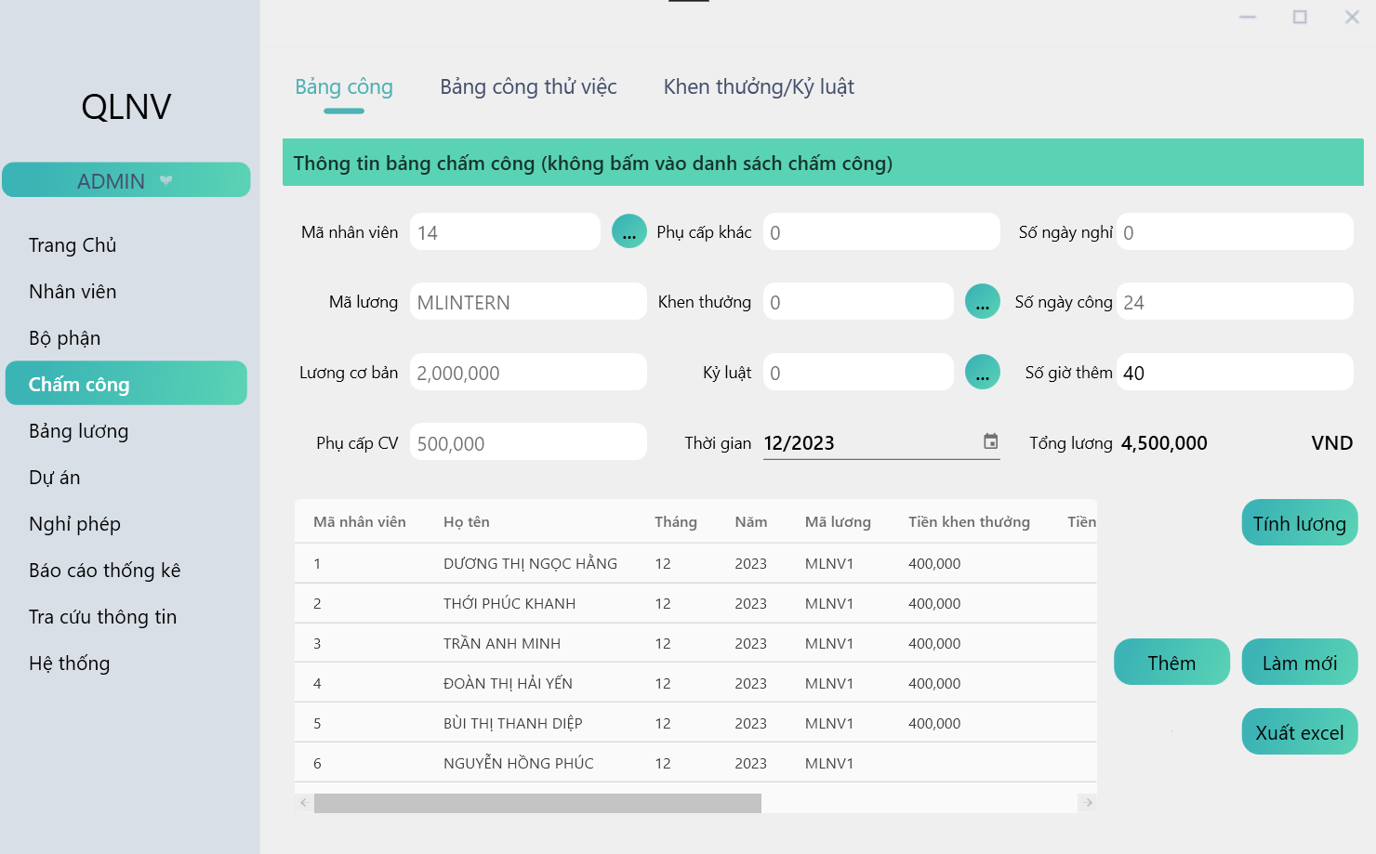

Figure 3. 1: Timesheet for interns

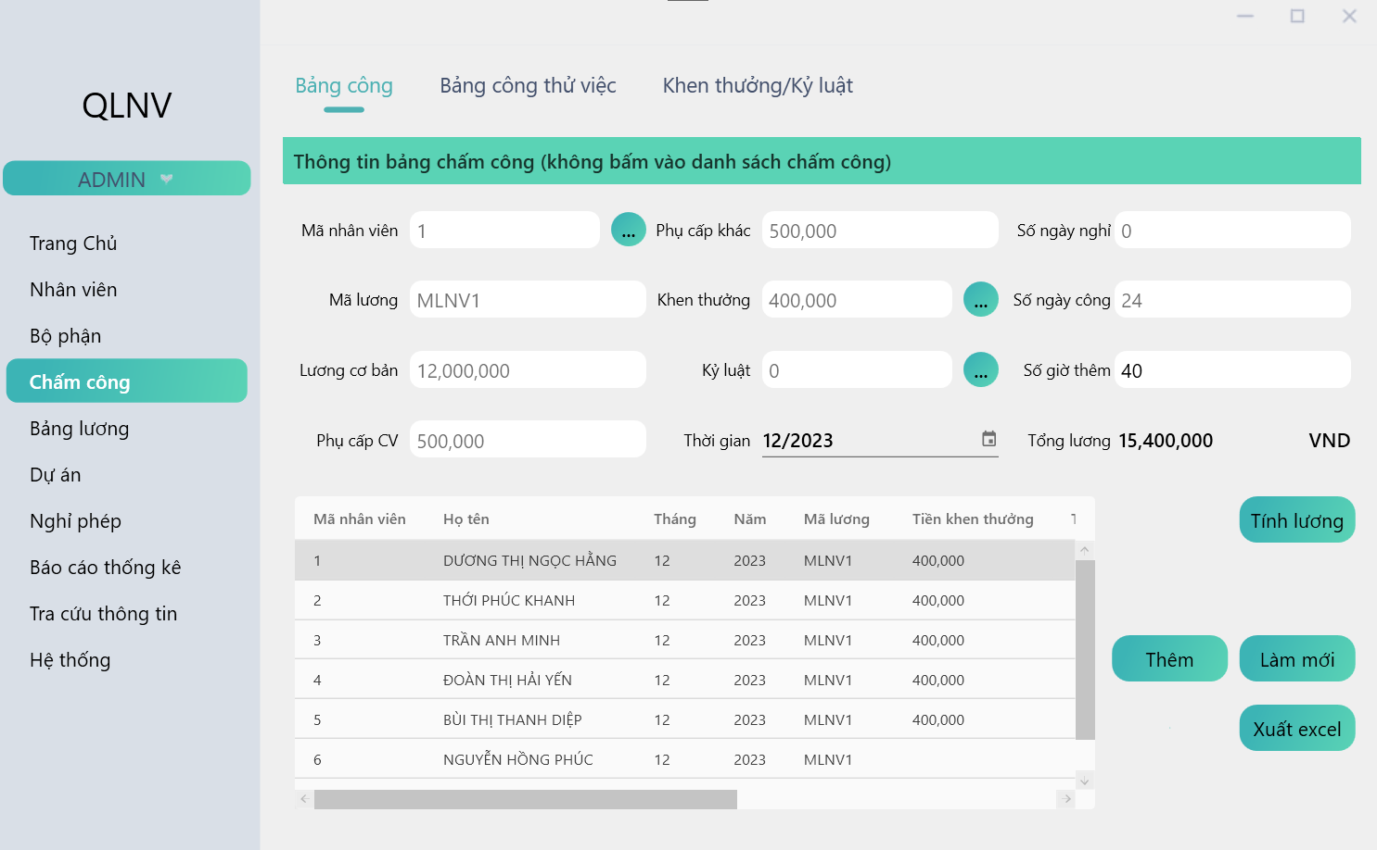

Figure 3. 2: Timesheet for employee

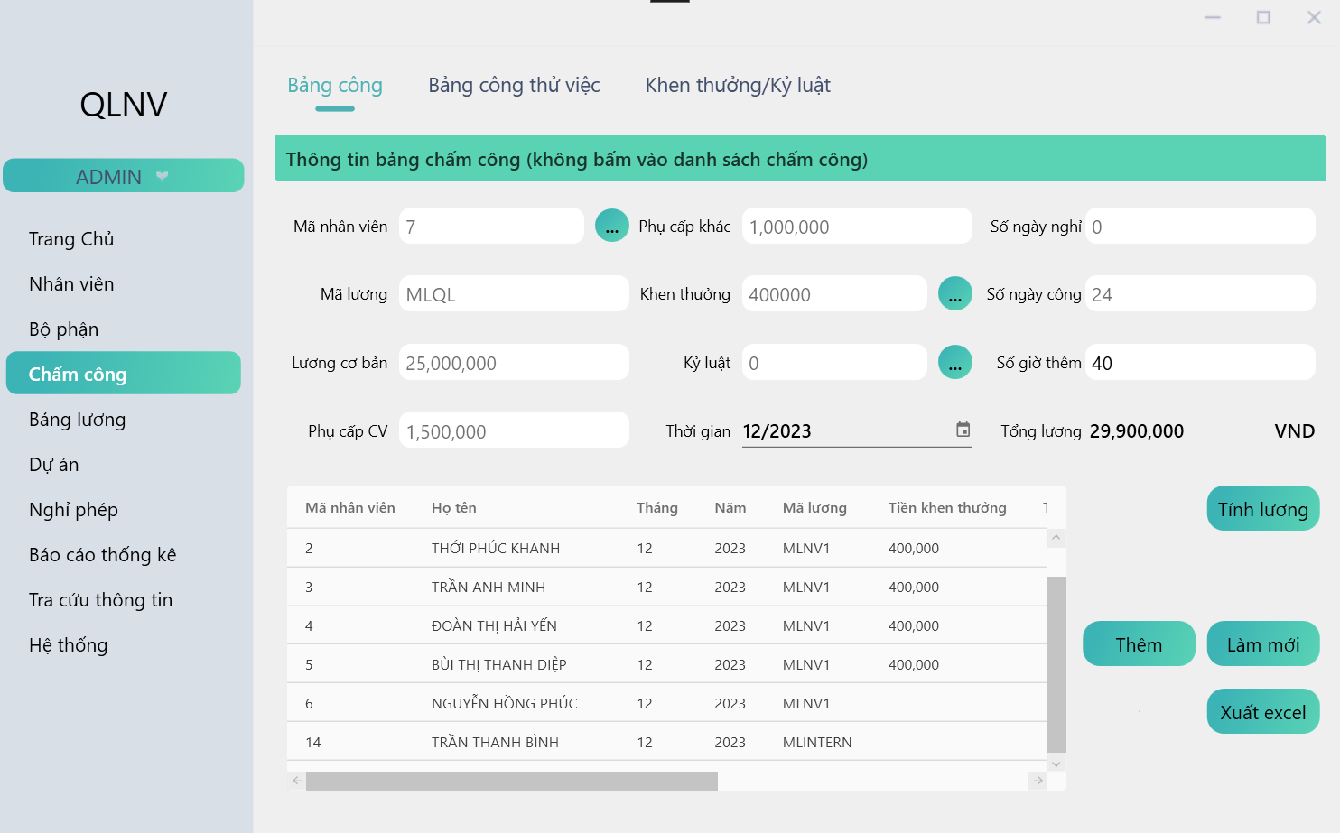

Figure 3. 3: Timesheet for management

**-** The software has bonus functions such as Tet bonuses, project bonuses and also has disciplinary measures

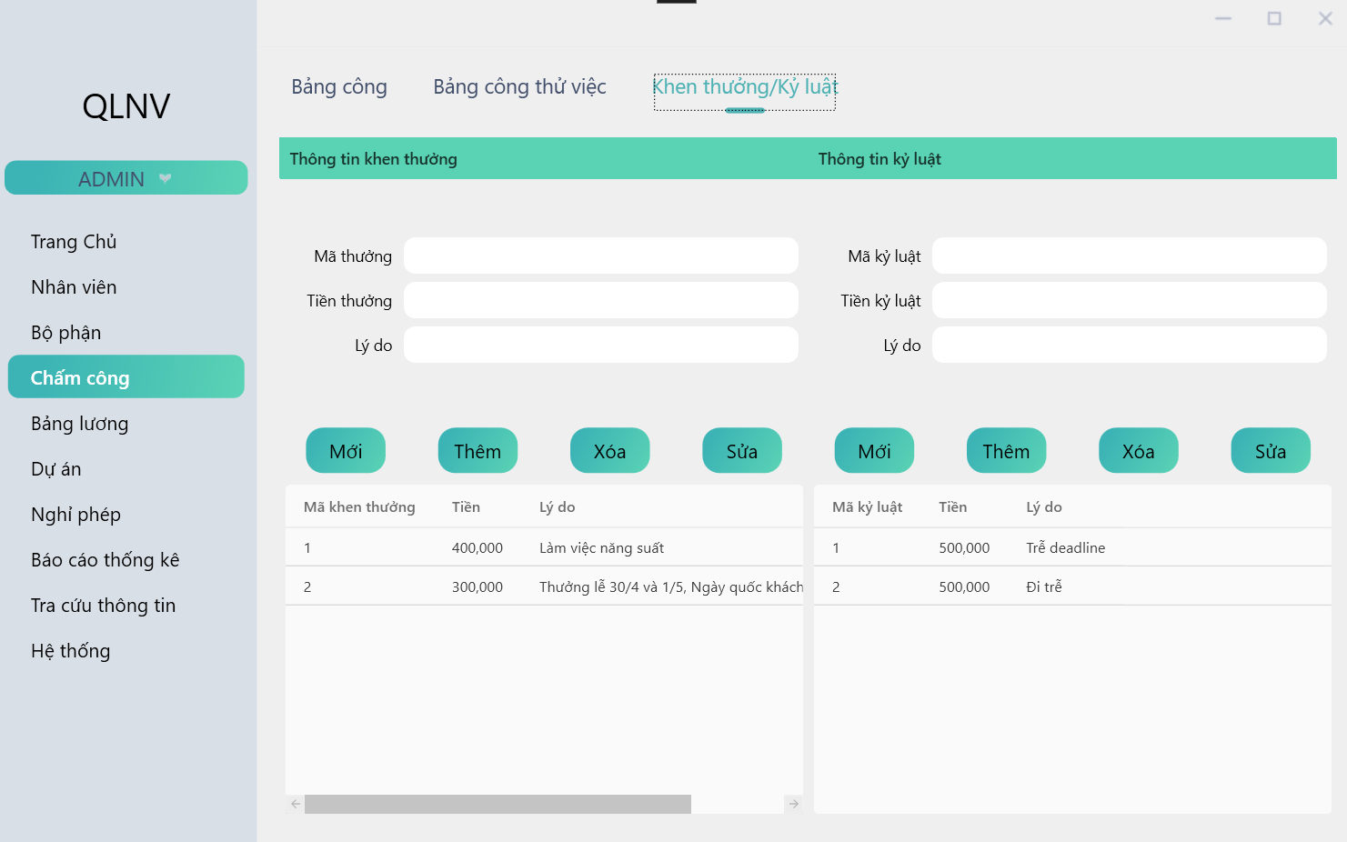

Figure 3. 4: List of awarded/ disciplined employees

## 3.2. System Analysis and Design

### **3.2.1. Determine requirements.**

**3.2.1.1. Methods of collecting documents**

- Information collection method:

• Research system documents:

From a survey of similar systems, the core functions of a basic HRMS have been identified from processes such as timekeeping, management, and discipline rewards….

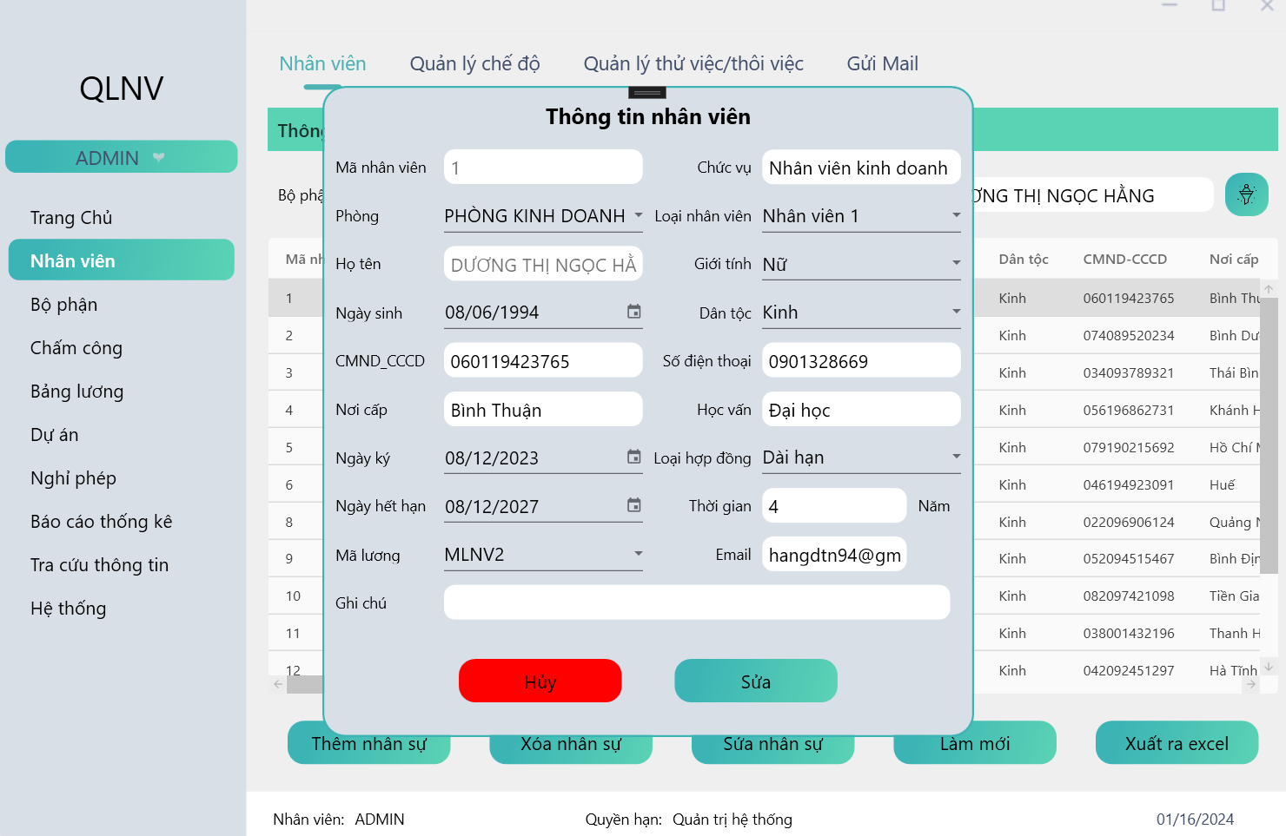

Figure 3. 5: Employee management function

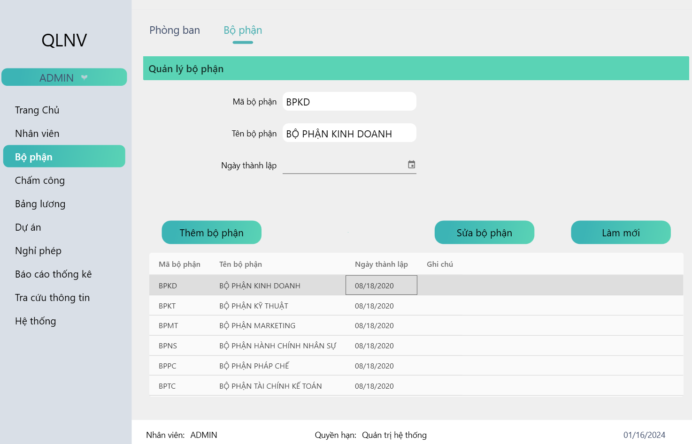

Figure 3. 6: Department management function

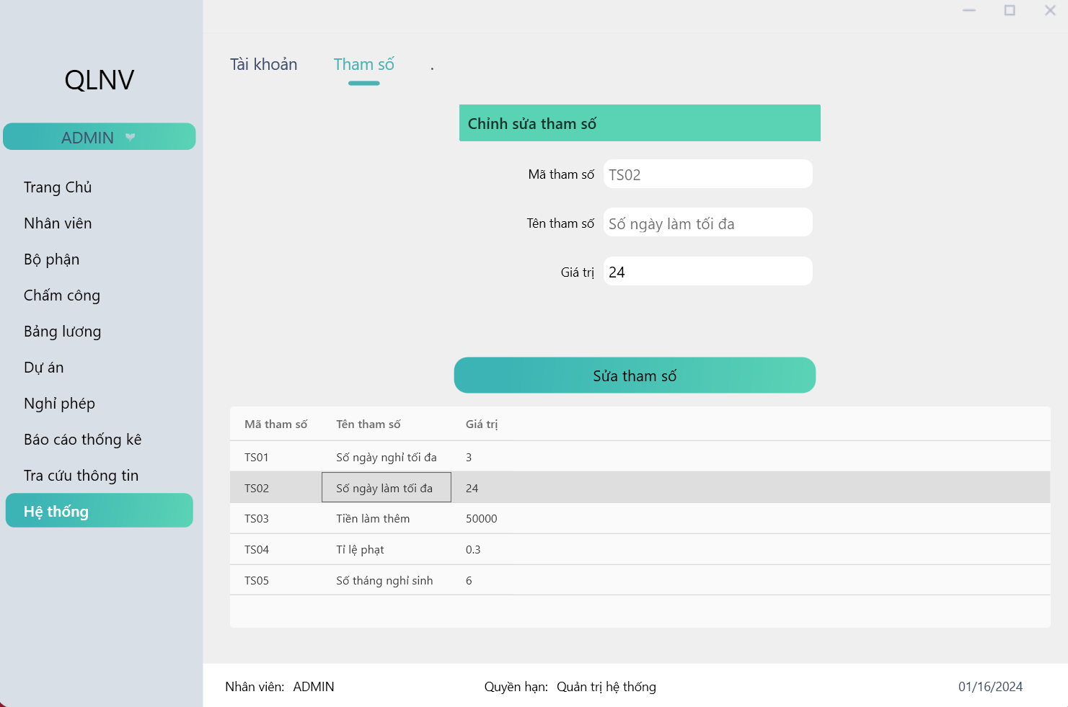

Figure 3. 7: Company management parameters

Specifically, it will include the following information:

* Employee code: Each employee will have his or her own fixed code that cannot be duplicated with others. After that employee leaves the job, that code should be kept intact and should not be assigned to someone else.
* Full name: Bui Duc Manh, Nguyen Hoang Duy, …..
* Departments and divisions: Marketing Department, Administration Department, Accounting Department….
* Type of personnel: BOD, Leader, manager, employee…
* Job position: Is the position the employee is taking, for example: Level 1 sales specialist, Level 2 sales specialist.
* Type of work: Full time, part time, seasonal…
* Information related to education: Education level (university, college...), school, major.
* Other necessary documents: Notarized copy of ID card or CCCD card, notarized copy of birth certificate, notarized copy of household registration book, Notarized copy of diploma……
* Information related to salaries, bonuses and allowances: Salary payment method (via card or cash), Bank account (which bank, branch), Number of dependents, Personal income tax code, Book number social insurance.
* Information related to work experience: Company name, position name, working period are arranged in chronological order.

*The necessity of applying information technology to human resource management:

For each business, professional human resource management is as complicated as financial or production management. For that reason, to support human resource management, it is necessary to apply IT as a human resource management system that helps minimize human effort, avoid errors and meet the basic requirements of managers.

- System approach:

Mobilizing and combining all resources to realize the overall goals of the company, calculating to understand and manage a system consisting of closely related processes before the set goal of building Build a human resource management system for company. That brings efficiency to work.

- Modeling method:

* Use case Diagram.
* Sequence Diagram.
* State Diagram.
* Class Diagram.
* Database Diagram.
* Process design.

**3.3.1.2. Collect, analyze and process data.**

After collecting the data (primary and secondary), synthesize, analyze, compare and evaluate the collected data, and some assessments can be drawn about the current state of management. Human resource management and the situation of human resource management information system at Hung Thinh Real Estate Company. From there, we can see the urgency of this thesis topic. At the same time, from the survey results, we will choose appropriate system analysis and design methods and processes, ensuring that we meet the set goals of the project.

### **3.3.2. Use Case Diagram**

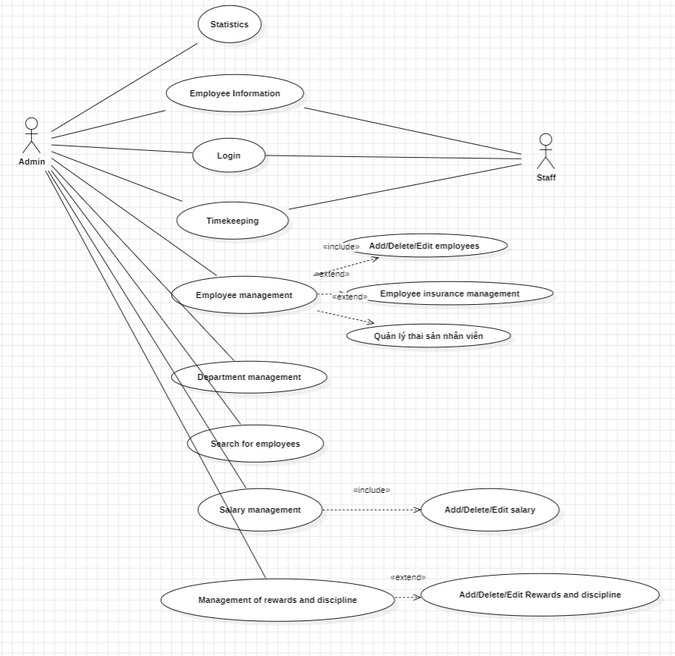

Figure 3. 8: Use case system.

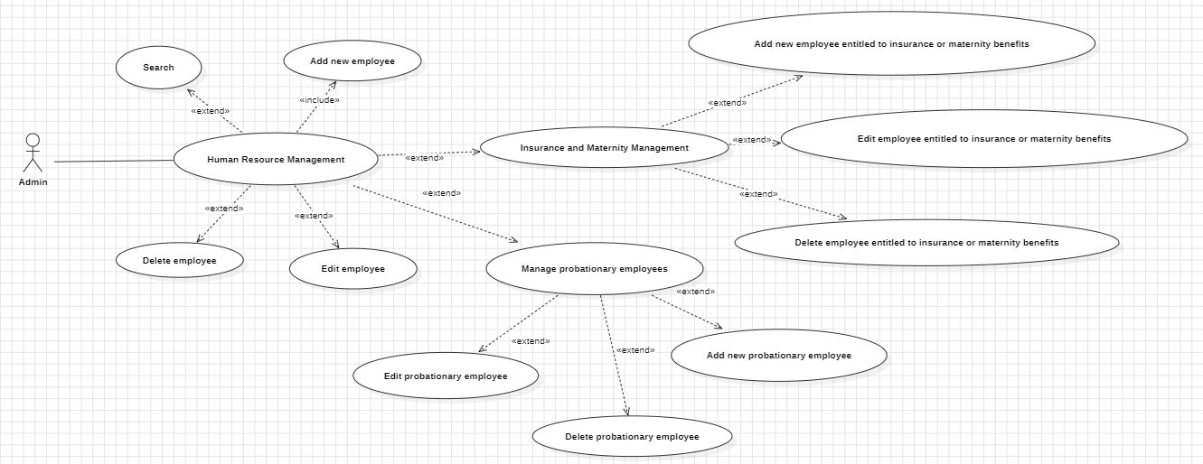

Figure 3. 9: Use case diagram Employee management.

### **3.3.3. Sequence Diagram**

* Login Sequence Diagram

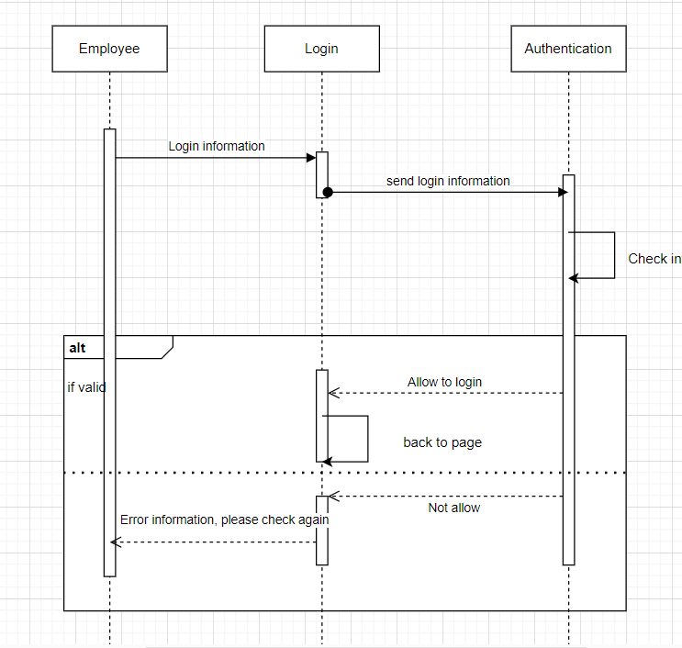

Figure 3. 10: Login Sequence Diagram

* Search Sequence Diagram

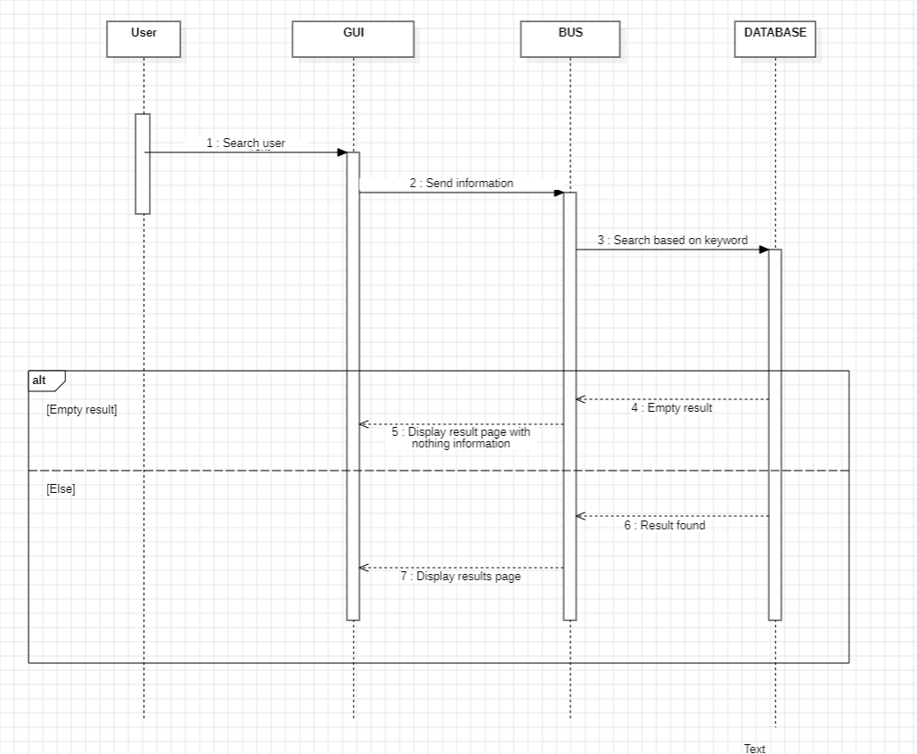

Figure 3. 11: Search Sequence Diagram

* Insert sequence diagram.

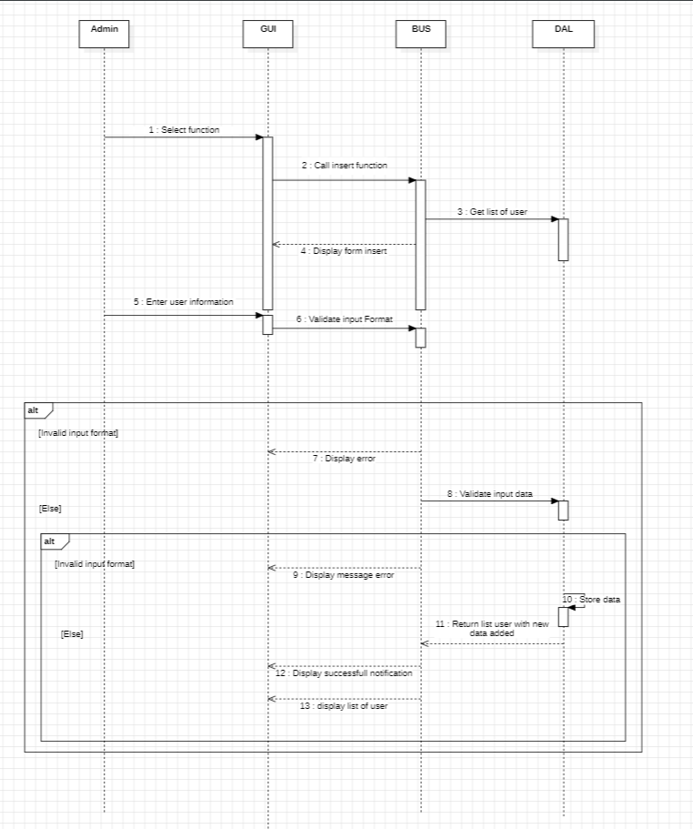

Figure 3. 12: Insert sequence diagram

* Update sequence diagram

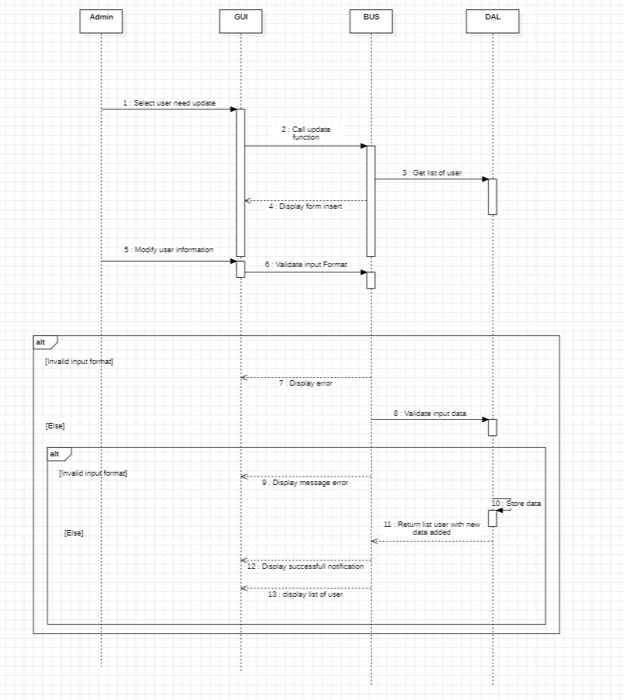

Figure 3. 13: Update sequence diagram

- Delete sequence diagram

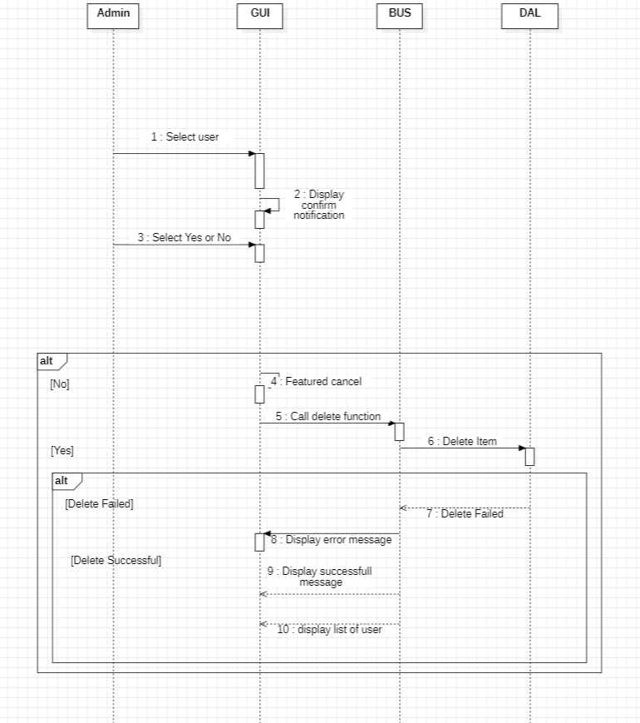

Figure 3. 14: Delete sequence diagram.

### **3.3.4. Class Diagram**

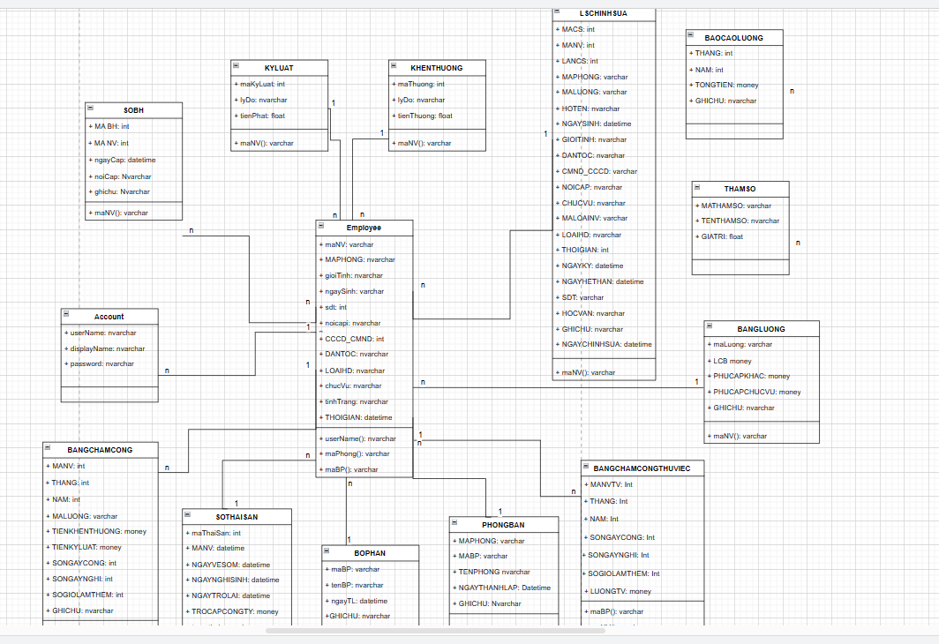

Figure 3. 15: Class Diagram

### **3.3.5. State Diagram**

+ State diagram of class “Employee profile”

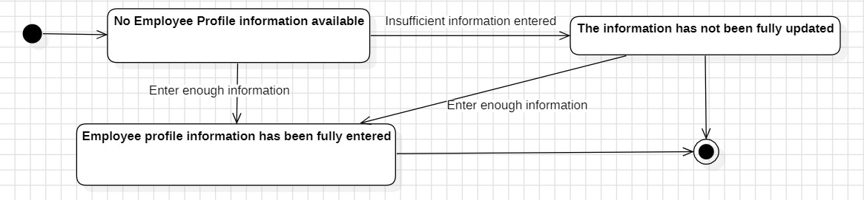

Figure 3. 16: State diagram of class “Employee Profile”

The status chart of the "Employee Profile" class above can be described as follows: the chart has 3 main statuses: "No HOSONV information", "HOSONV information available", "No information available" and two sub-states are the initial state and the final state.

* The employee profile is initialized in the state "No HOSONV information".
* The employee profile changes from the status "No HOSONV information" to the status "There is HOSONV information" when the HR staff enters all information.
* The employee profile changes from the status "No HOSONV information" to the status "No information has been updated" when the human resources staff enters missing information.
* The employee profile changes from the status "Information has not been updated" to the status " HOSONV information is available" when the human resources staff continues to enter enough information.

+ “Search” class state diagram:

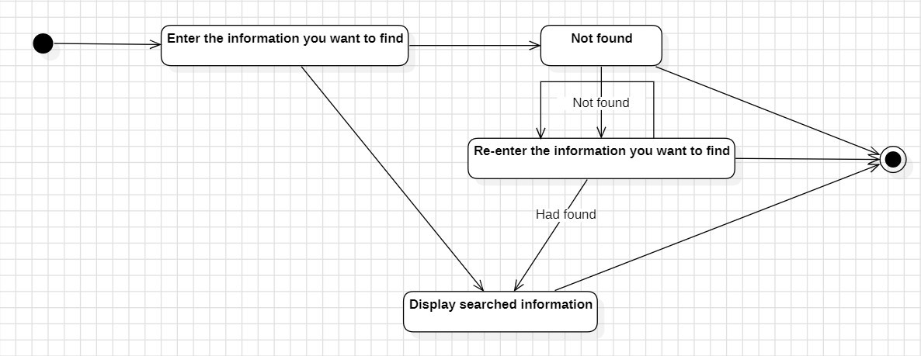

Figure 3. 17: Search Diagram

The state chart of the "Search" class above can be described as follows: The chart has 4 main statuses: "Enter search information", "Can't find anything", "Show information" and " Enter the finding information" and two sub-states are the initial state and the end state.

* Search initializes in the state "Enter search information".
* The search changes from the state "Enter information to search for" to the state "Show information" when the user enters valid search information.
* The search changes from the state "Input information to search for" to the state "Can't find" when the user enters the information to search for invalid.
* The search changes from the "Can't find" state to the "Re-enter search information" state if the user requests to re-enter the search information.
* The search changes from “Re-enter search information" to the "Show information" state if the user re-enters valid search information.

+ "Reward - Discipline" class state diagram:

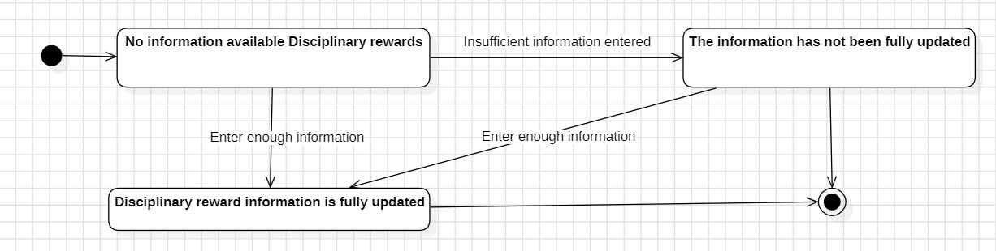

Figure 3. 18: Reward – Discipline Diagram

The status chart of the "Reward - Discipline" class above can be described as follows: The chart has 3 main statuses: "No economic information - Result", "There is economic information - Result", “The information is not the most updated”, and two sub-states are the initial state and the final state.

* Employee information is initialized in the state "No technical information - KL information".
* Employee information changes from the state "No technical information - KL" to the state "There is technical information - KL" when the human resources staff enters all information.
* The employee profile changes from the state "No technical information - KL" to the state "Information is not updated" when the human resources staff enters missing information.
* The employee profile changes from the status "Information has not been updated at most" to the status "There is technical information - KL" when the human resources staff continues to enter enough information.

​

+ "Insurance" class state diagram:

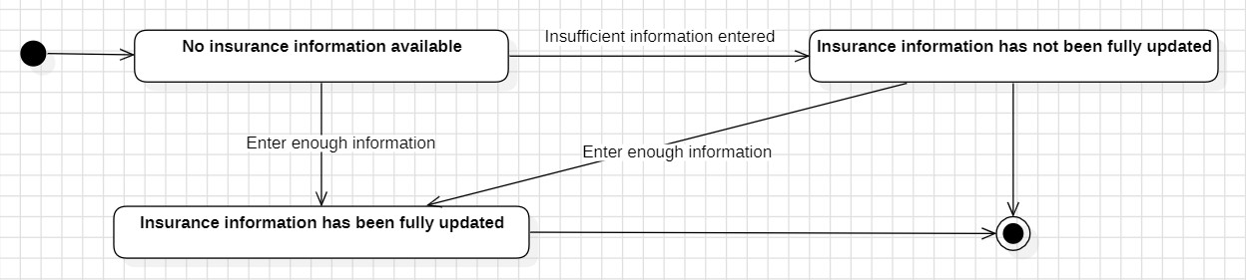

Figure 3. 19: Insurance Diagram

The status chart of the "Insurance" layer above can be described as follows: The chart has 3 main statuses: "No insurance information", "Insurance information available", "Insurance information not available". most captivated today", and two sub-states are the initial state and the final state.

* Employee information is initialized in the state "No insurance information".
* Employee information changes from the state "No insurance information" to the state "Insurance information available" when the human resources staff enters all information.
* Employee information changes from the state "No insurance information available" to the state "Information is not updated" when the human resources staff enters missing information.
* Employee information changes from the state "Information has not been updated" to the state "Insurance information is available" when the human resources staff continues to enter enough information.

### **3.3.6. Database design**

- Data relationships between tables:

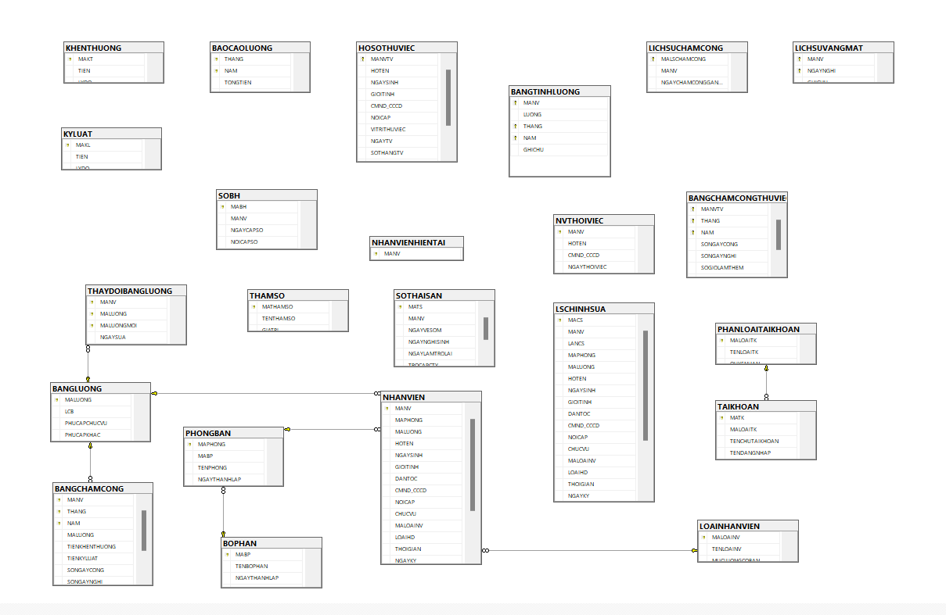

Figure 3. 20: Human resource management software data relations.

- List of entities and properties:

**Nhanvien** (manhanvien, ten, ngaysinh, gioitinh, sdt, cmt, trinhdo, machucvu, tenchucvu, maphongban, tenphongban, luong, trangthai).

**Danhgia** (madanhgia, manhanvien, machucvu, tenchucvu, machucvumoi, tenchucvumoi, trangthai).

**Chucvu** (machucvu, ten).

**Phongban**(maphongban, ten, trangthai).

**Calamviec** (maca, manhanvien, ten, thoigian)

**Nghiphep** (manghiphep, manhanvien, ngay, loainghi, trangthai).

**Chedonghi** (machedonghi, manhanvien, loainghi, tungay, denngay, trangthai).

**Chamcong** (ngay, manhanvien, thoigianbatdau, thoigianketthuc).

**Khenthuongkyluat** (maktkl, manhanvien, ngay, sotien, ghichu, trangthai, hinhthuc).

**Hesoluong** (mahesoluong, ten, heso, loaiheso).

- Designing database tables:

Table 3. 1: Store employee information

|  |  |  |
| --- | --- | --- |
| **Employee** | | |
| **Field data name** | **Data type** | **Description** |
| manhanvien | int | Employee ID |
| hoten | nvarchar(50) | Employee name |
| ngaysinh | datetime | Date of birth |
| gioitinh | nvarchar(4) | Gender |
| sdt | varchar(10) | Phone number |
| cccd | varchar(12) | Citizen identification card |
| hocvan | nvarchar(20) | Level |
| machucvu | int | Position ID |
| tenchucvu | nvarchar(100) | Position Name |
| maphongban | varchar(10) | Department ID |
| tenphongban | nvarchar(100) | Department Name |
| luong | Decimal(18,0) | Salary |
| trangthai | int | status |

Table 3. 2: Store employee position information.

|  |  |  |
| --- | --- | --- |
| **Position** | | |
| **Field data name** | **Data type** | **Description** |
| machucvu | Int | Position ID |
| tenchucvu | nvarchar(100) | Position name |

Table 3. 3: Store department information.

|  |  |  |
| --- | --- | --- |
| **Department** | | |
| **Field data name** | **Data type** | **Description** |
| maphongban | int | Department ID |
| tenphongban | nvarchar(100) | Department name |
| trangthai | int | Status |

Table 3. 4: Store employee timekeeping information.

|  |  |  |
| --- | --- | --- |
| **Timekeeping** | | |
| **Field data name** | **Data type** | **Description** |
| ngay | datetime | Timekeeping date |
| manhanvien | int | Employee ID |
| thoigianbatdau | datetime | Start date |
| thoigianketthuc | datetime | End date |

Table 3. 5: Store employee evaluation information.

|  |  |  |
| --- | --- | --- |
| **Evaluation** | | |
| **Field data name** | **Data type** | **Description** |
| madanhgia | int | Evaluation ID |
| manhanvien | int | Employee ID |
| machucvu | nvarchar(50) | Position ID |
| tenchucvu | nvarchar(100) | Position Name |
| machucvumoi | nvarchar(50) | New Position ID |
| tenchucvumoi | nvarchar(100) | New Position Name |
| trangthai | nvarchar(50) | Status |

Table 3. 6: Store employee reward and discipline information.

|  |  |  |
| --- | --- | --- |
| **Reward and discipline** | | |
| **Field data name** | **Data type** | **Description** |
| maktkl | int | Reward and discipline ID |
| manhanvien | int | Employee ID |
| ngay | datetime | day |
| sotien | decimal(18,0) | Amount of money |
| ghichu | nvarchar(500) | Note |
| hinhthuc | int | form |
| trangthai | nvarchar(50) | Status |

Table 3. 7: Store employee on leave information.

|  |  |  |
| --- | --- | --- |
| **On leave** | | |
| **Field data name** | **Data type** | **Description** |
| manghiphep | int | On leave ID |
| manhanvien | int | Employee ID |
| ngay | datetime | On leave day |
| loainghi | int | On leave type |
| trangthai | int | Status |

Table 3. 8: Store employee leave information.

|  |  |  |
| --- | --- | --- |
| **Resting mode** | | |
| **Field data name** | **Data type** | **Description** |
| machedonghi | int | Rest ID |
| manhanvien | int | Employee ID |
| loainghi | int | On leave type |
| tungay | datetime | Start date |
| denngay | datetime | End date |
| trangthai | int | Status |

Table 3. 9: Store employee leave information.

|  |  |  |
| --- | --- | --- |
| **Coefficients salary** | | |
| **Field data name** | **Data type** | **Description** |
| mahesoluong | int | Coefficients salary ID |
| ten | nvarchar(100) | Employee name |
| heso | float | Coefficients |

Table 3. 10: Store employee shift information.

|  |  |  |
| --- | --- | --- |
| **Shift** | | |
| **Field data name** | **Data type** | **Description** |
| maca | int | Shift ID |
| manhanvien | int | Employee ID |
| Ten | nvarchar(100) | Shift name |
| thoigian | int | Time |

**3.3.7. Process Design.**

**- Login process:**

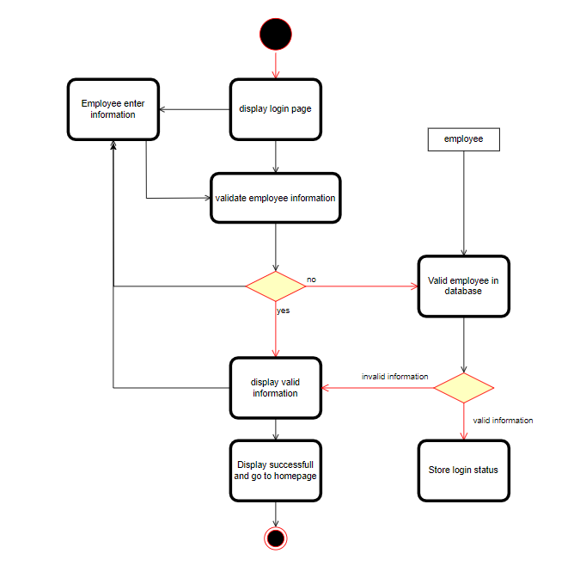

Figure 3. 21: Login Process.

When opening the software, users must enter their account and password. If the software is missing, there will immediately be a message "Please enter your full account name and password". If the first condition is met, the software continues to check if the account and password exist in the database. If not, there will be a message: "Input wrong account or password", then the user will must log in again.

**- Search process:**

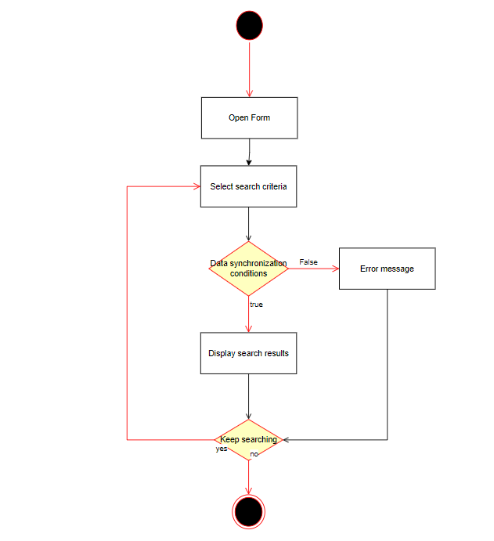

Figure 3. 22: Search Process

The user logs in to the software, selects search, enters the data to be searched, if the wrong conditions are selected, an error message will be sent and asked to re-enter, the user will re-enter the data they want to search, after being satisfied. search conditions, the program will display results. If the user wants to continue searching, they will return to entering search conditions, otherwise they will exit the program.

**- Updated process:**

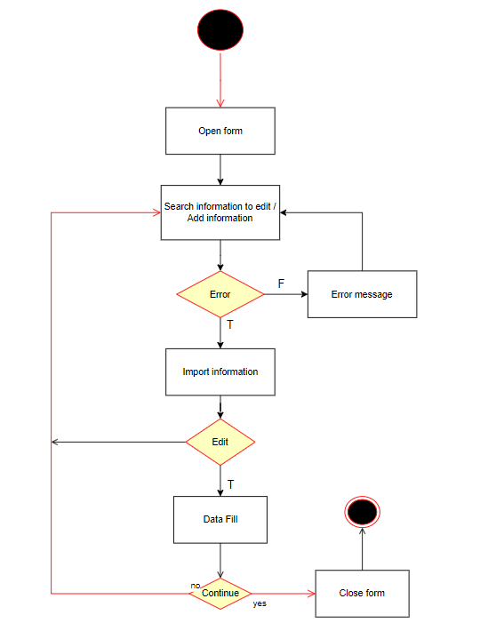

Figure 3. 23:Updated Process

The user logs into the program, goes to a category tab. To add a new one, the user will press the "add new" button to add a new line of data, the user enters the code, and information related to the category. If there is an error, a notification will appear, and the user must act on it. When the conditions are met, new information can be added or updated.

**- Report printing process:**

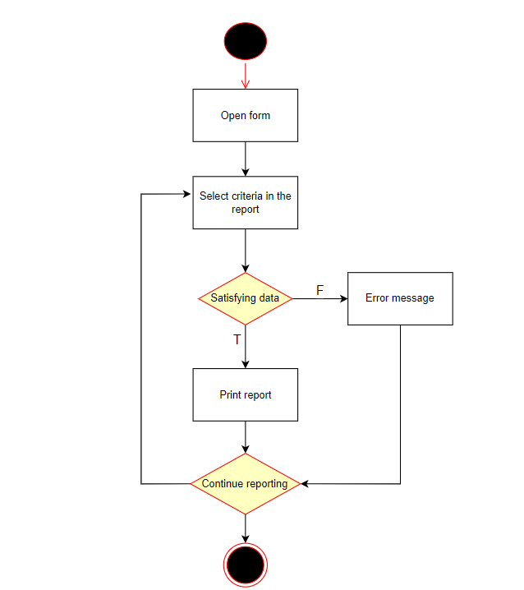

Figure 3. 24: Report Printing Process

The user logs into the program, selects each feature to print a report for each feature, and enters filtering conditions, if any. After completing the input and ensuring there are no errors, the program will display the report results and the user can print it out.

**- Insert diagram:**

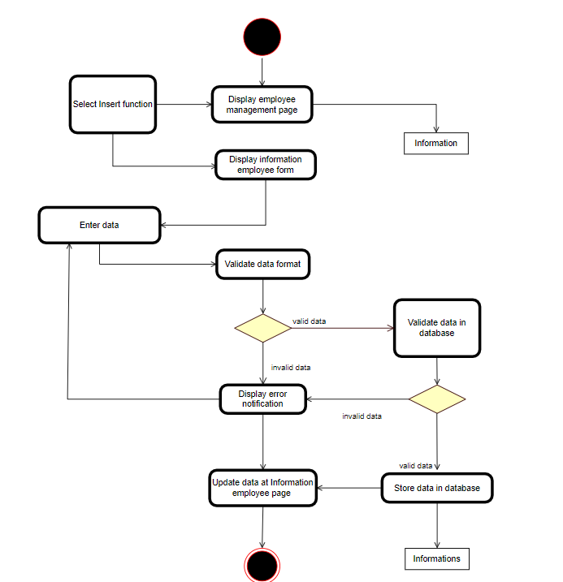

Figure 3. 25: Insert information diagram.

Admin logs into the program and selects additional employees. After completing the process of adding employees, the new employee results will be displayed and managed.

# **CHAPTER 4: IMPLEMENTATION RESULTS**

## 4.1. System development technologies

• Technologies used in this thesis:

- **SQL Server:** Store and retrieve data as required by other software applications.

- **C#, .NET Framework [4]:** It provides libraries, tools, and standards for building and running applications, including memory management and error handling.

- **WPF Framework:** Used to build applications for workstations running the Windows operating system.

- **Star UML:** Design and draw diagrams and illustrations, especially suitable for designing system descriptions.

## 4.2. System functions - Software functions:

**\* ADMIN ROLES:**

+ Login function

- Allows users to log into the software system to perform functions to manage human resources for the company.

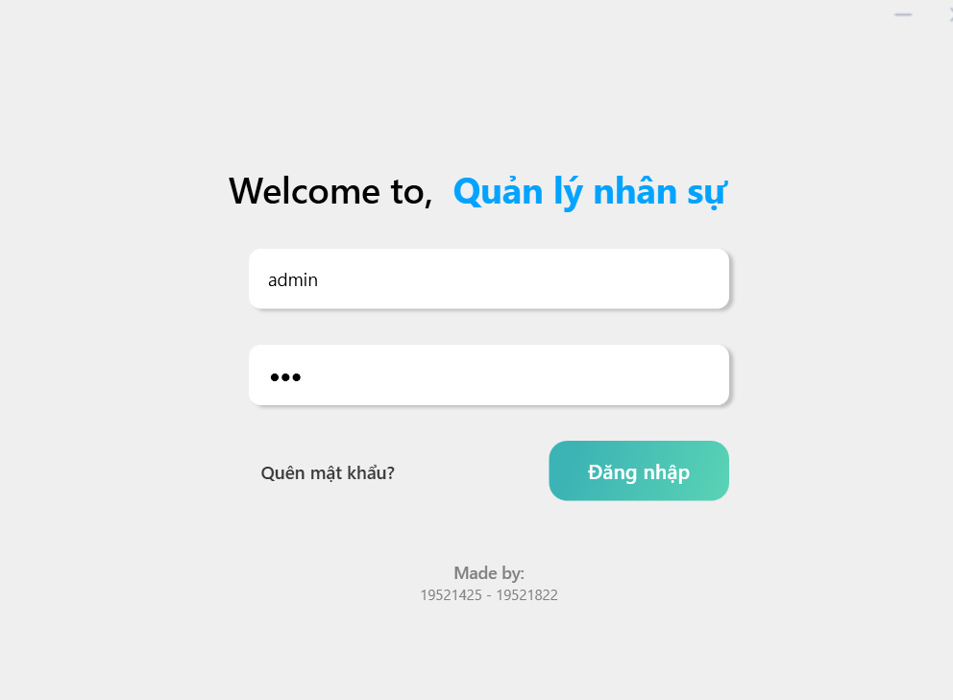

*Figure 4. 1: Login interface*

**+ Employee management function.**

- Allows users to perform employee management functions such as: View list, add, delete, edit, search and calculate employee salaries

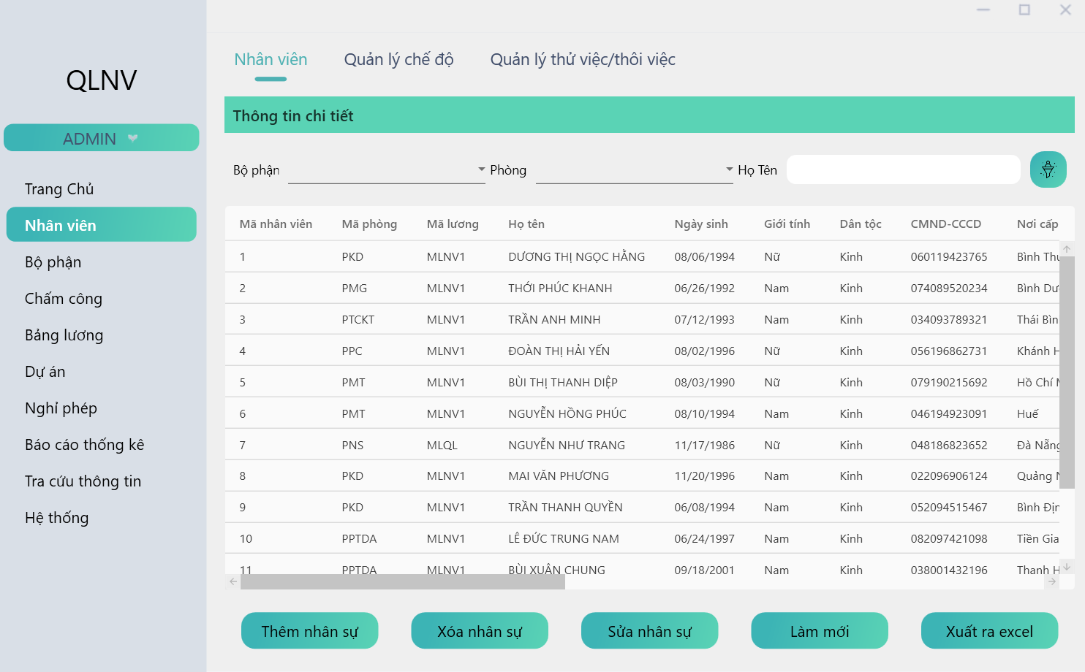

*Figure 4. 2: Employee list management screen.*

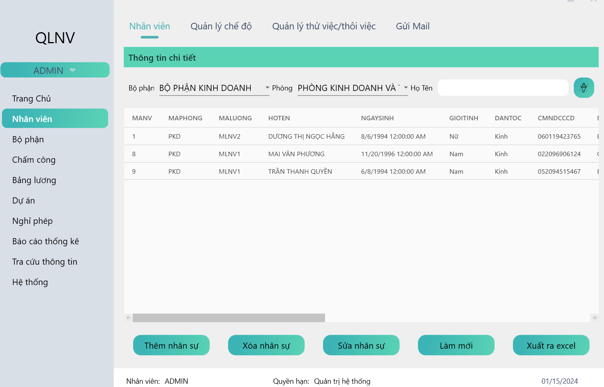

*Figure 4. 3: Employees by department*

- The function allows users to export employee lists to Excel files.

**+ Send Email function.**

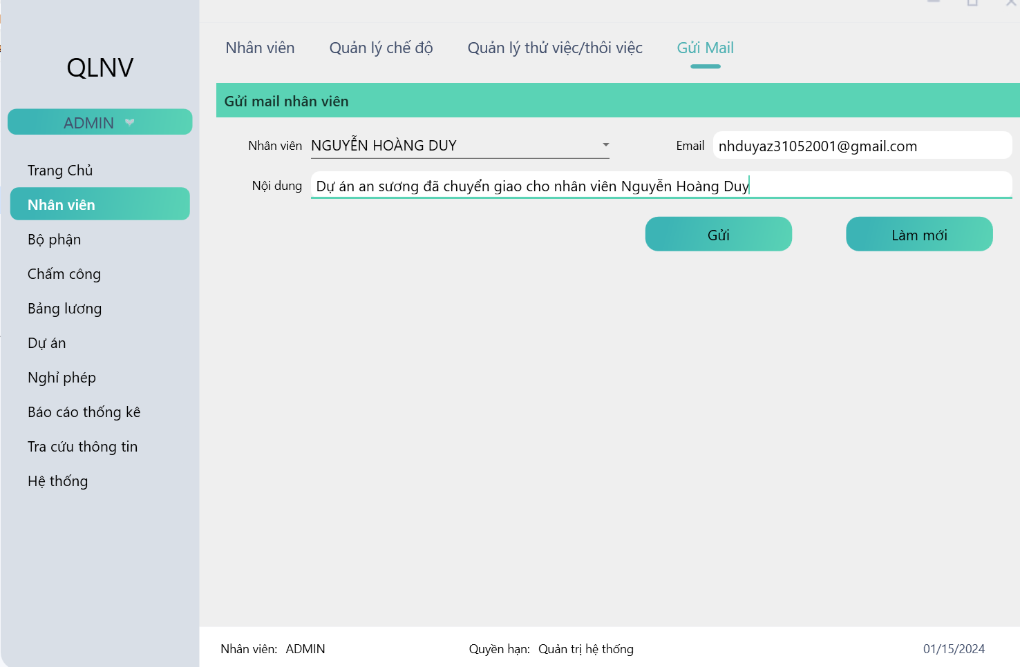

*Figure 4. 4: Email messages interface*

Function sends message to personal email involving to the project.

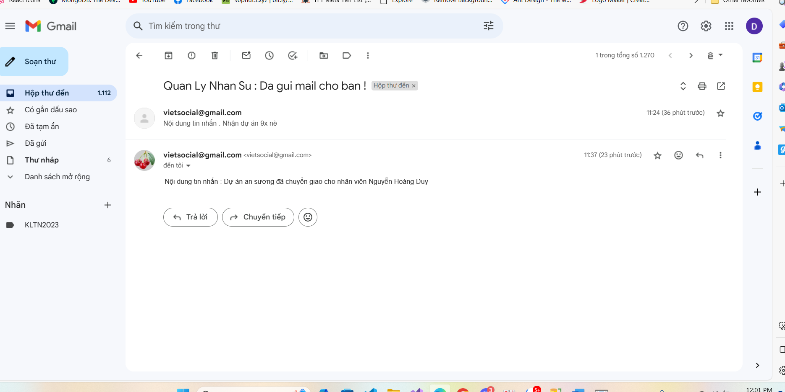

*Figure 4. 5: Email messages result*

**+ Department management function.**

- Allows users to perform department management functions such as: View list, add, delete, edit.

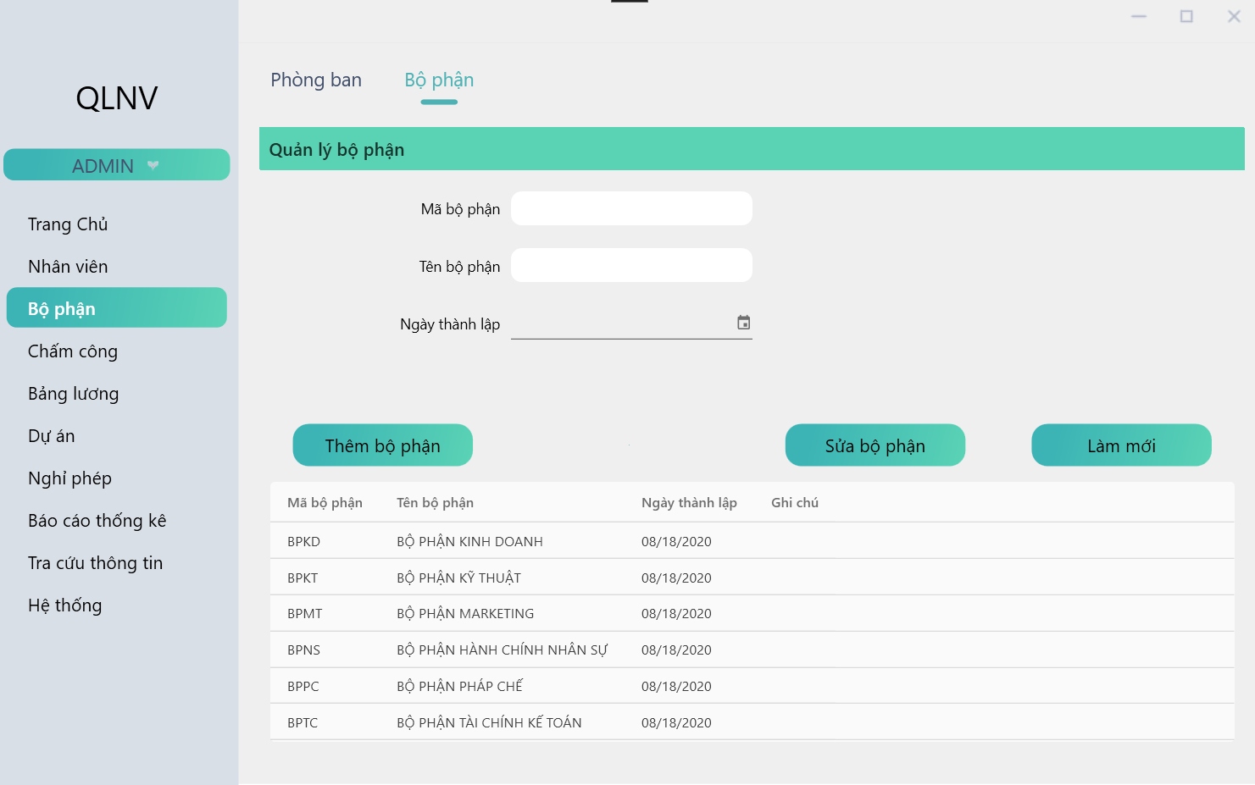

*Figure 4. 6: Department management screen.*

**+ Position management function.**

- Allows users to perform position management functions such as: View list, add, delete, edit.

**+ Salary coefficient management function.**

- Allows users to perform salary coefficient management functions such as: View list, add, delete, edit.

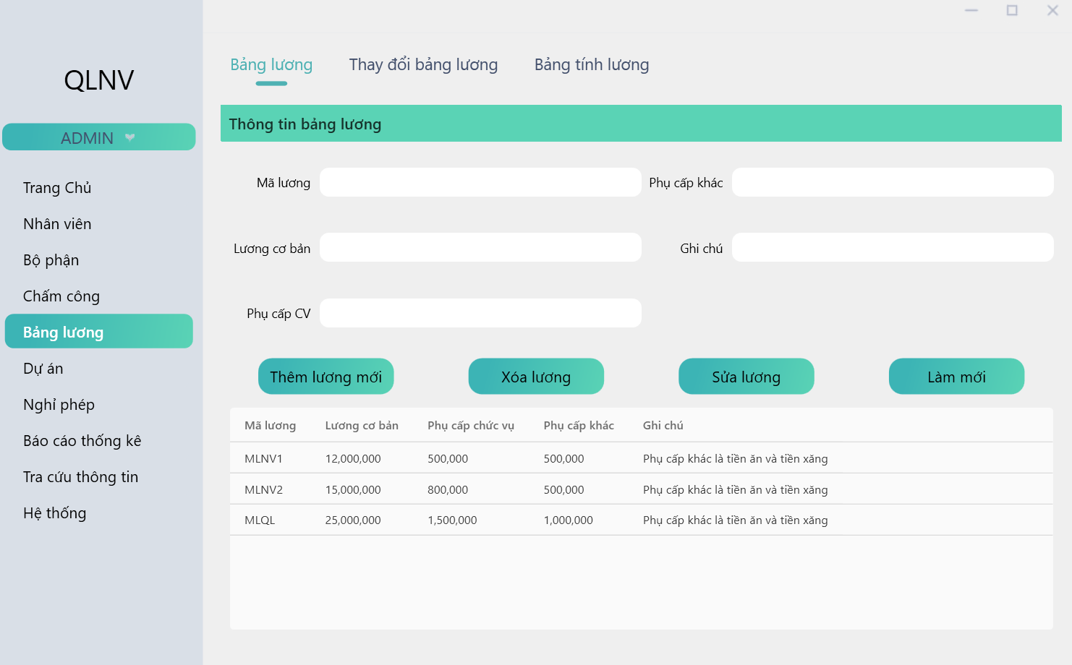

*Figure 4. 7: Salary management screen.*

**+ Change Payroll**

Review the salary increase process for employees during the working process  
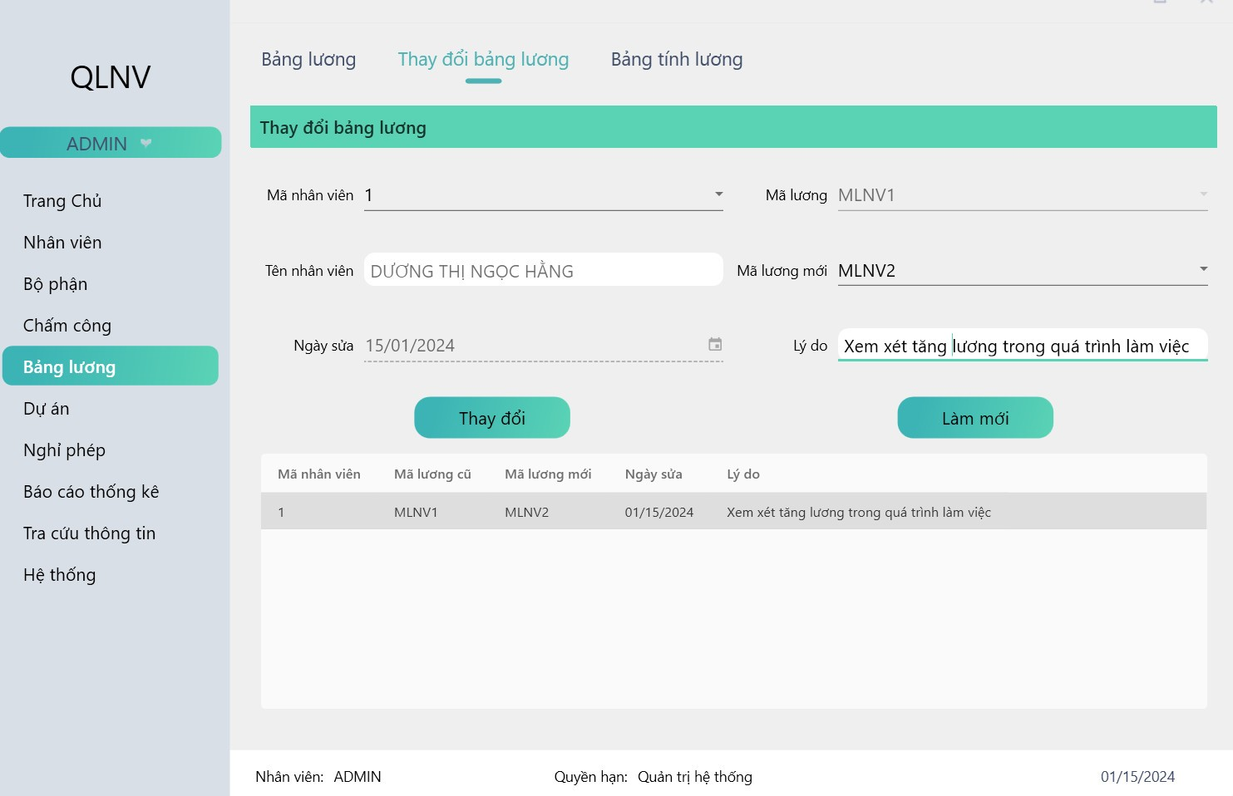

*Figure 4. 8: Change payroll screen*

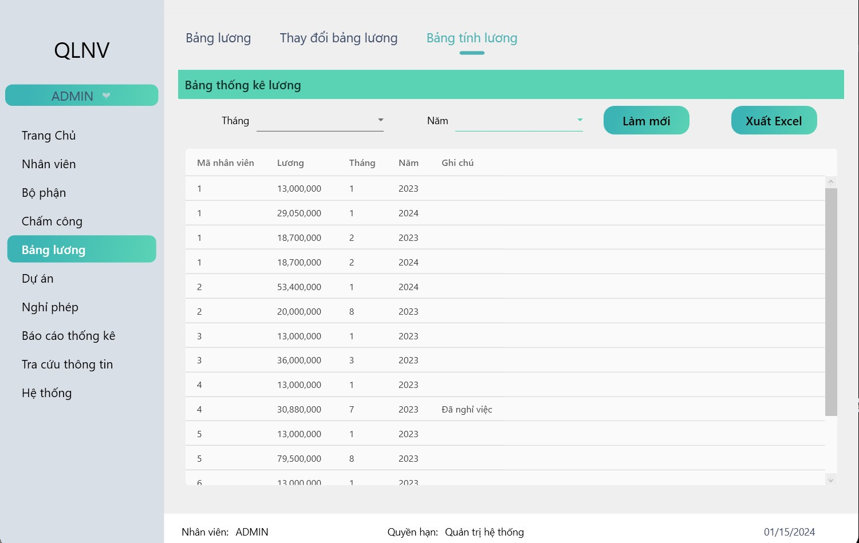

*Figure 4. 9: General salary schedule*

**+ Reward / discipline management function.**

- Allows users to reward or discipline employees and the corresponding amount, this amount will be calculated when receiving the employee's monthly salary

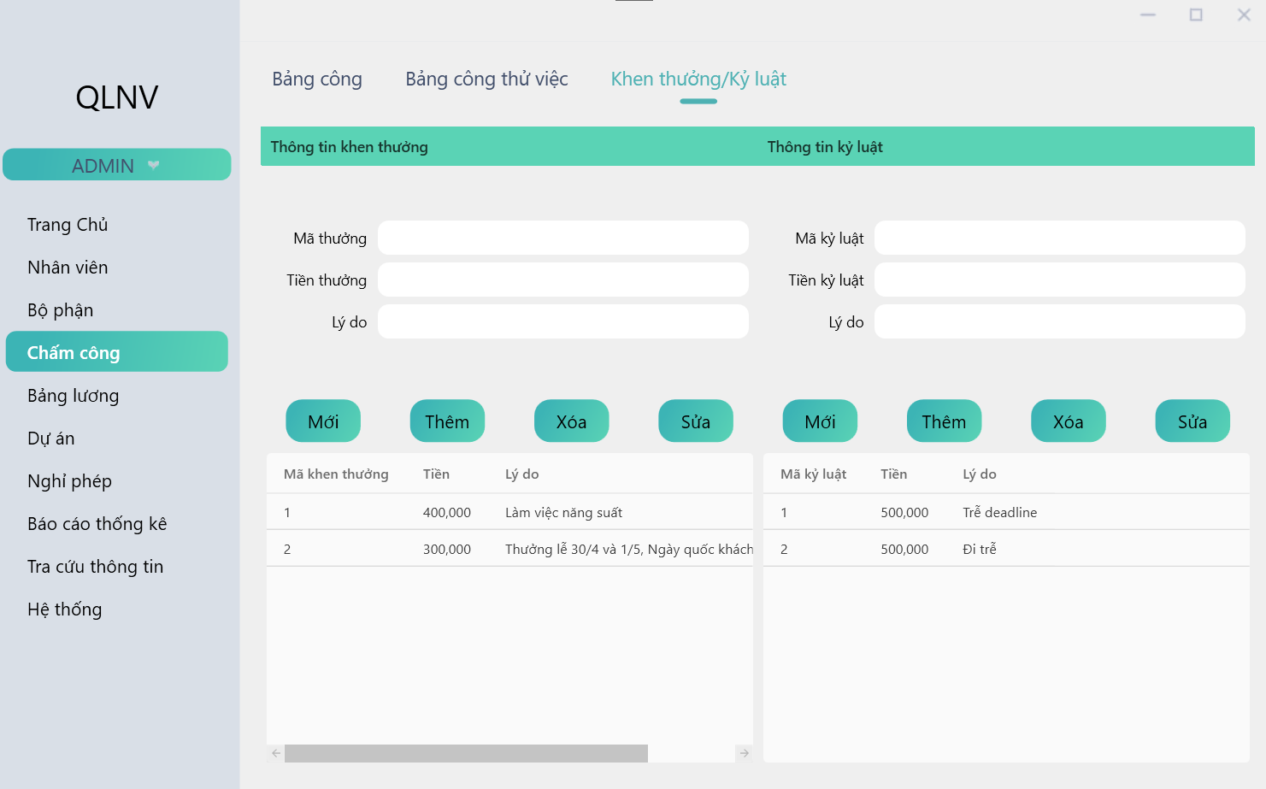

*Figure 4. 10: Reward / Discipline management screen.*

**+ Timekeeping management function.**

- Allows people to time clock employees, the function will save the employee's starting and ending hours at the time of timekeeping.

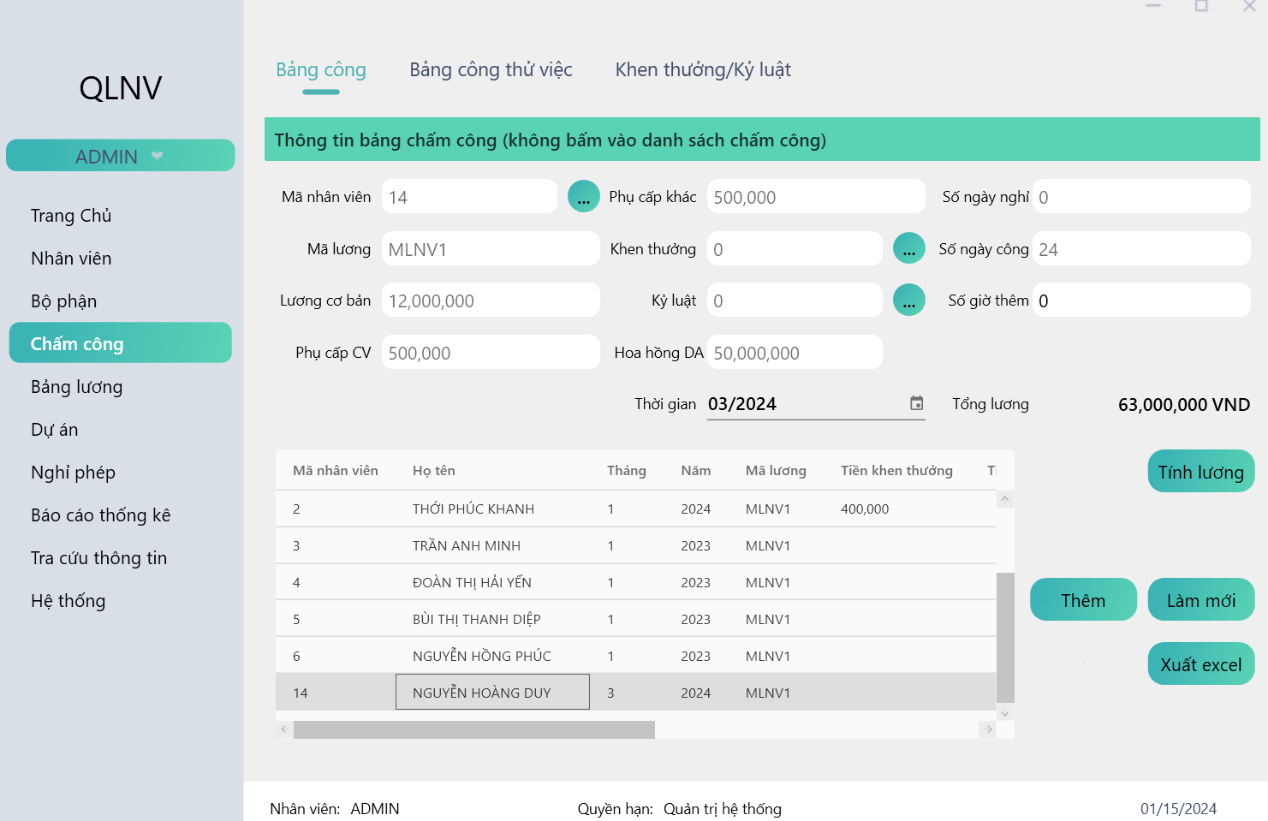

*Figure 4. 11: Timekeeping management screen*

**+ Project assignment function**

- Allow employees to register for projects and receive commissions according to the level set by the company

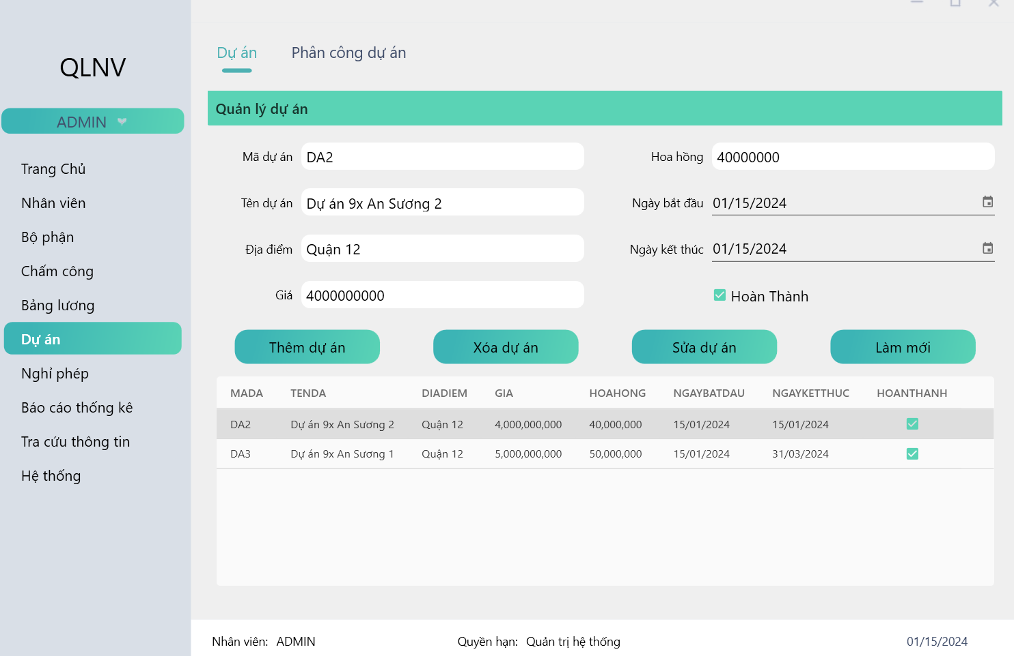

*Figure 4. 12: Project management screen*

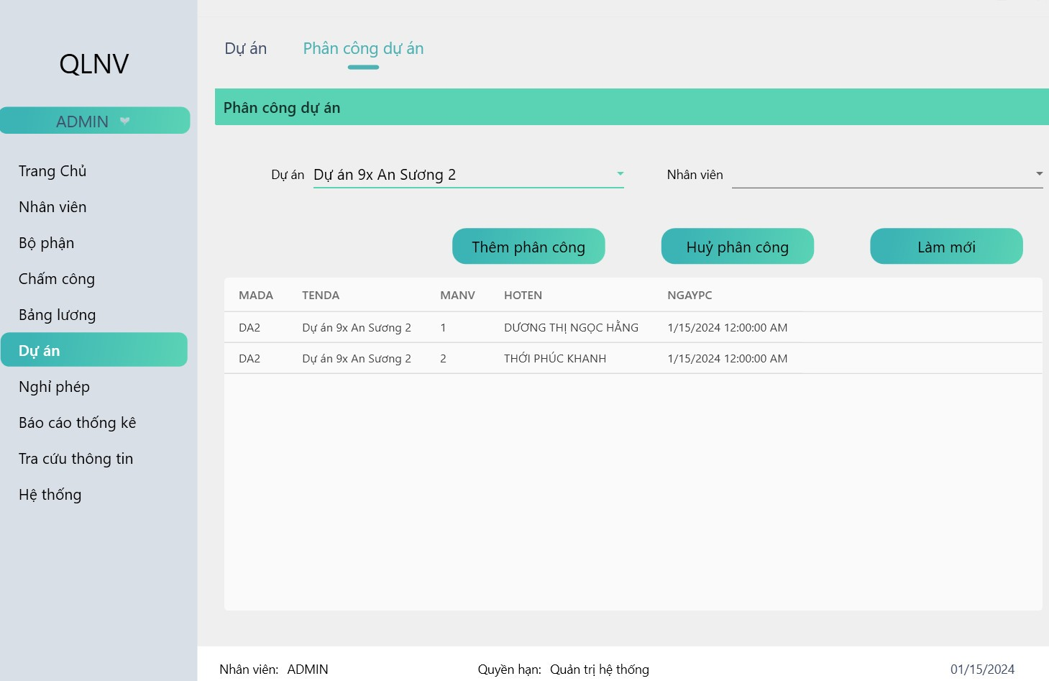

*Figure 4. 13: Employee assigned project screen*

**+ Leave application approval function**

- Employees apply for leave using the provided account and managers can approve the application from the system

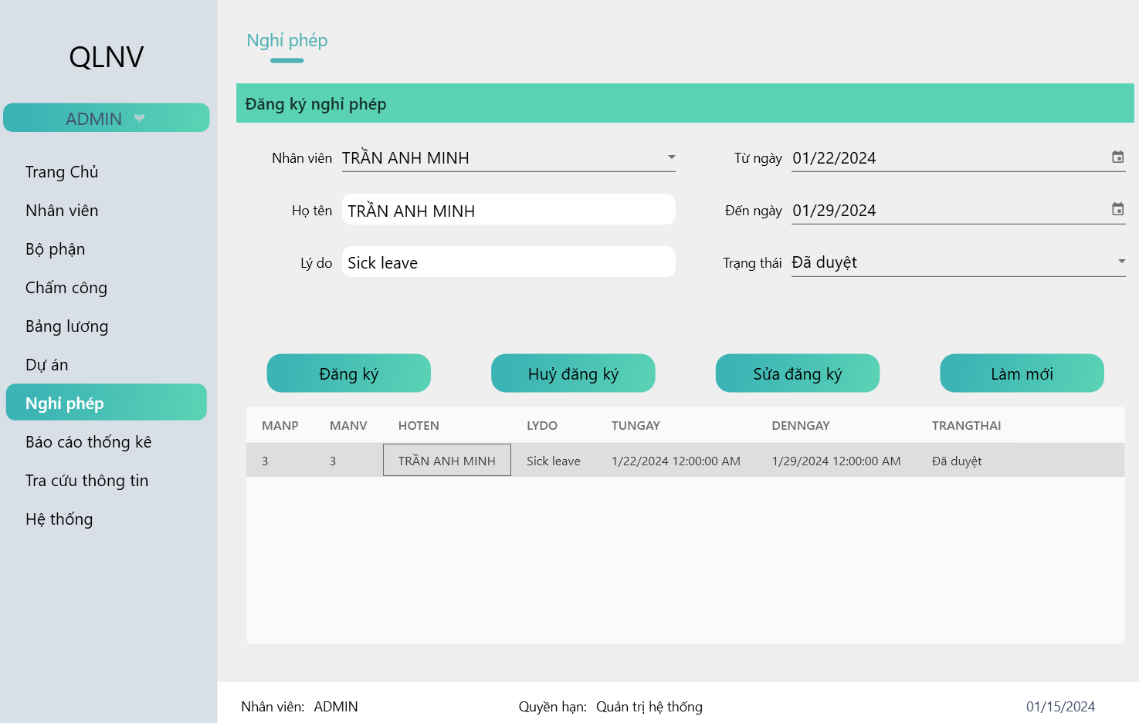

*Figure 4. 14: Application for leave screen*

**+ Statistics function.**

- Statistics on employees entering, probationary and quitting jobs

- Statistics of management about salary.

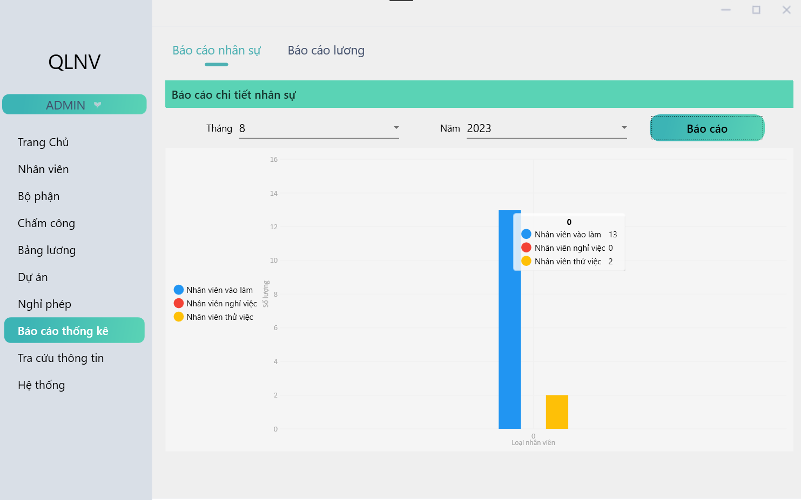

*Figure 4. 15: Statistical users screen*

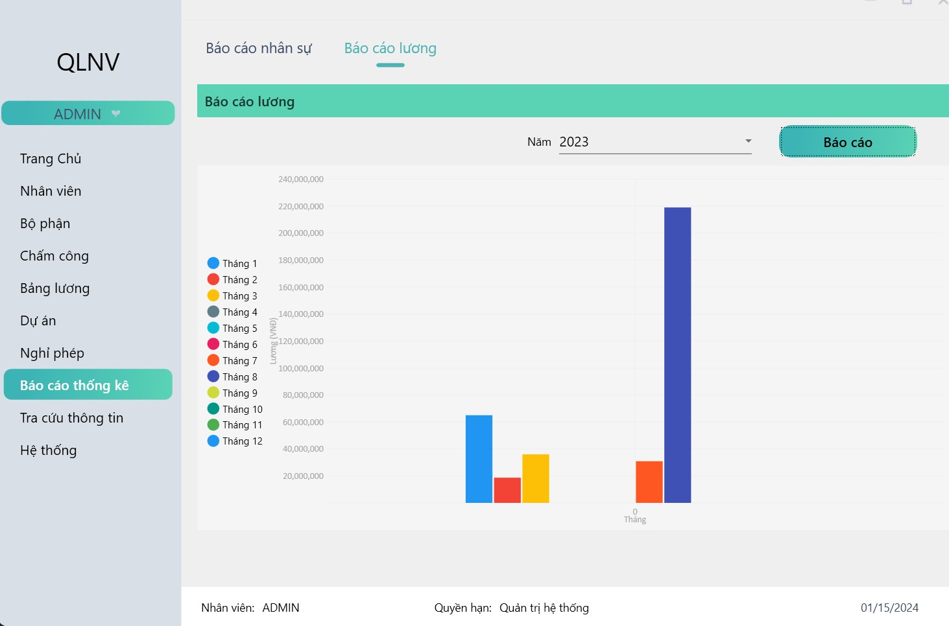

*Figure 4. 16: Company salary statistics in 2023*

**+ Leave management function.**

- Each employee is allowed to resign for many reasons, the function allows users to enter employee resignation information into the software system as well as edit and delete.

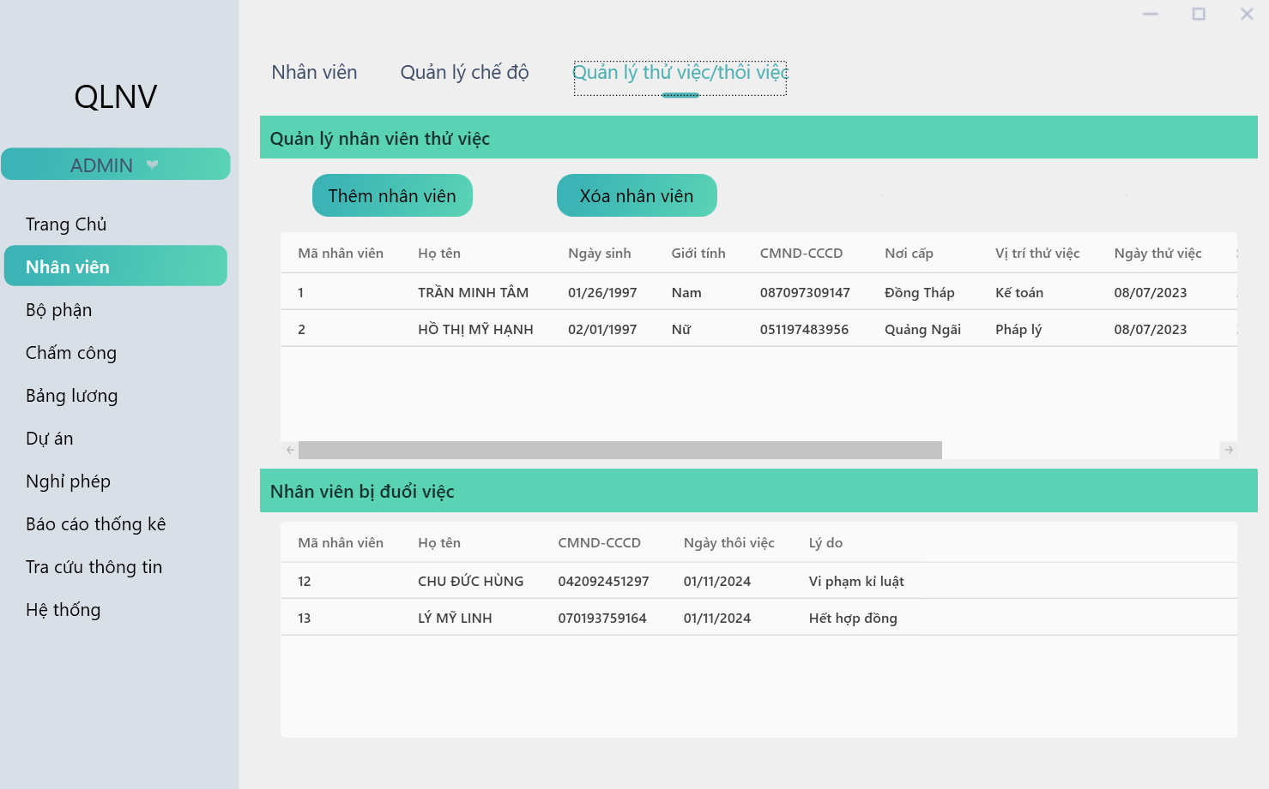

*Figure 4. 17: Dismissal employee interface.*

**+ Reporting function.**

- To serve the reporting of employee information to superiors, the software supports reporting functions

- Reporting forms include:

• Monthly payroll

• List of people with the highest salary

• Report total salary for the month

• Report total salary by year

• List of employees on sick leave

You can export the report list to an Excel file.

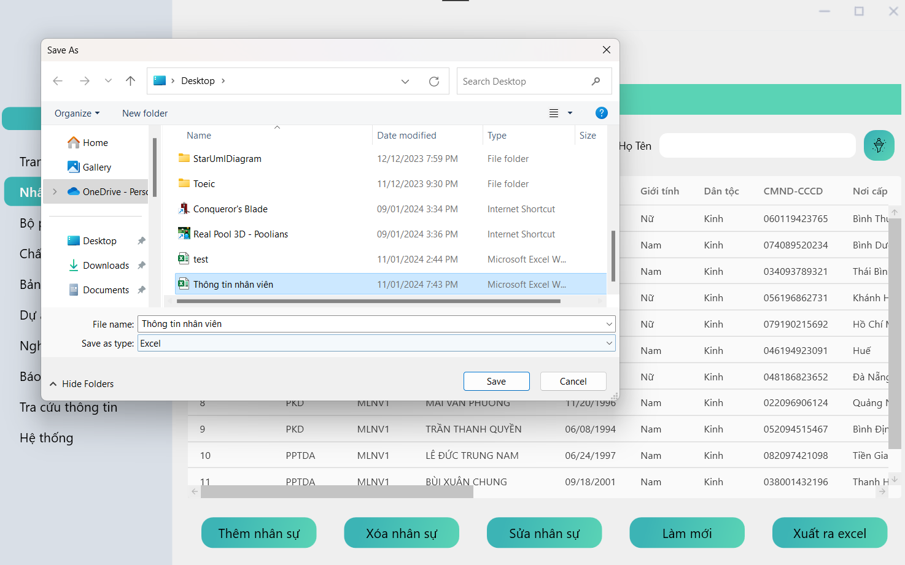

*Figure 4. 18: Export report to excel screen*

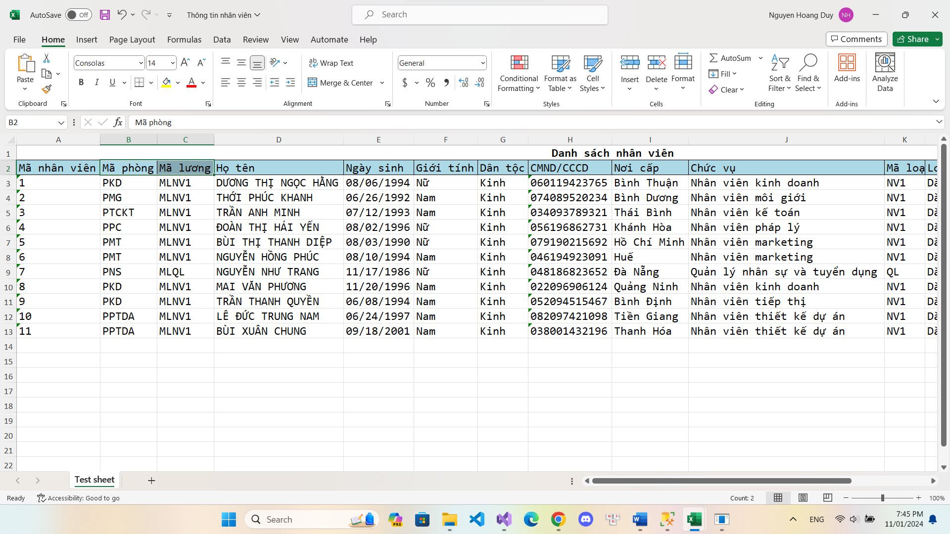

*Figure 4. 19: Result of excel screen.*

**+ Project function.**

- Can add project, location, price and commission received on that project.

- Can assign employees to each project and when the project is completed, the employee will receive 5% commission calculated into the payroll.

***\** USER ROLES:**

**+ Login function:**

**-** Allow to each user login by personal account to manage information

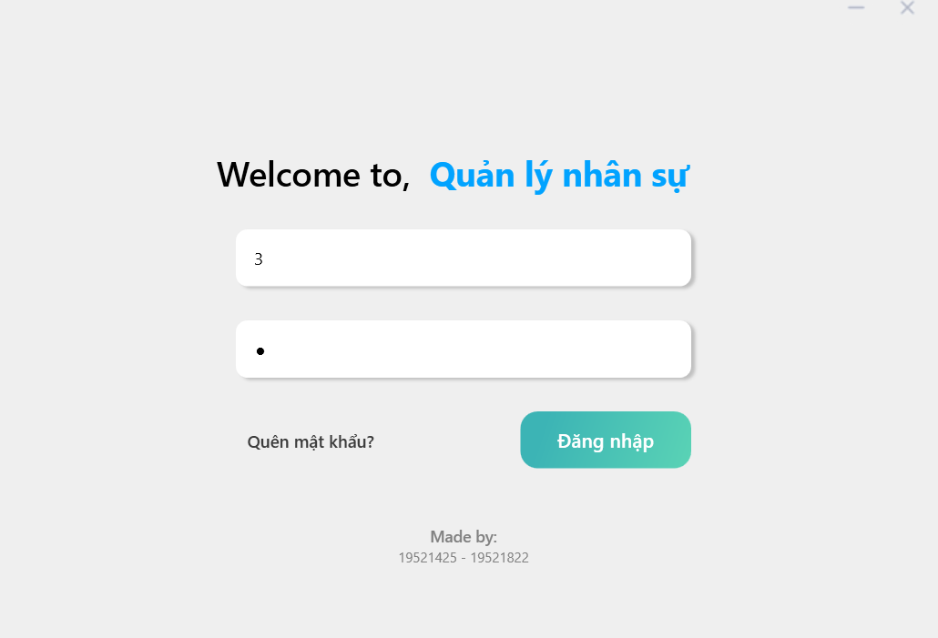

*Figure 4. 20: Login user screen.*

**+ Information management**

- User can manage information by edit, watch history edit

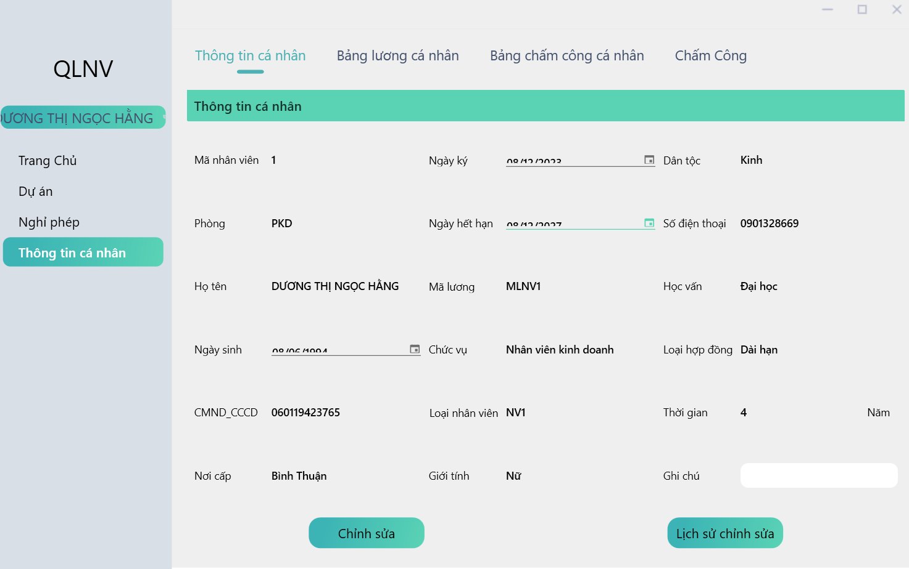

*Figure 4. 21: Information user screen.*

**+ Personal salary schedule:**

- Users can view personal payroll and payroll information such as basic salary and allowances

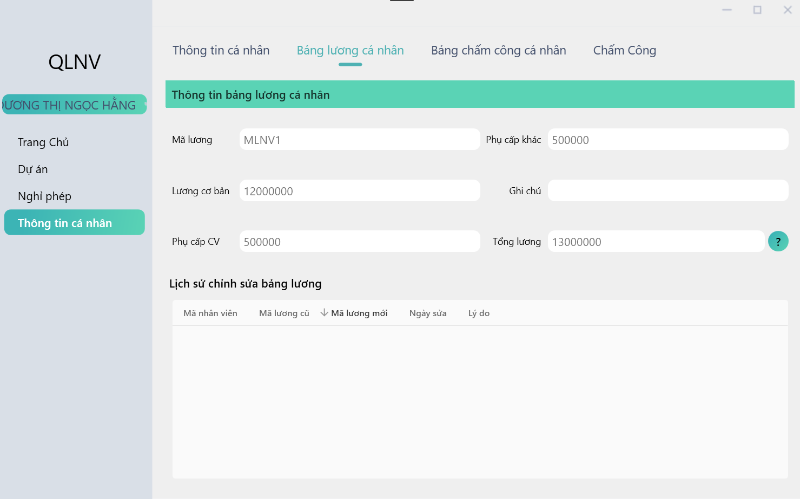

*Figure 4. 22: Information salary user screen.*

**+ Personal timesheet:**

- Users can view individual timesheets for each month.

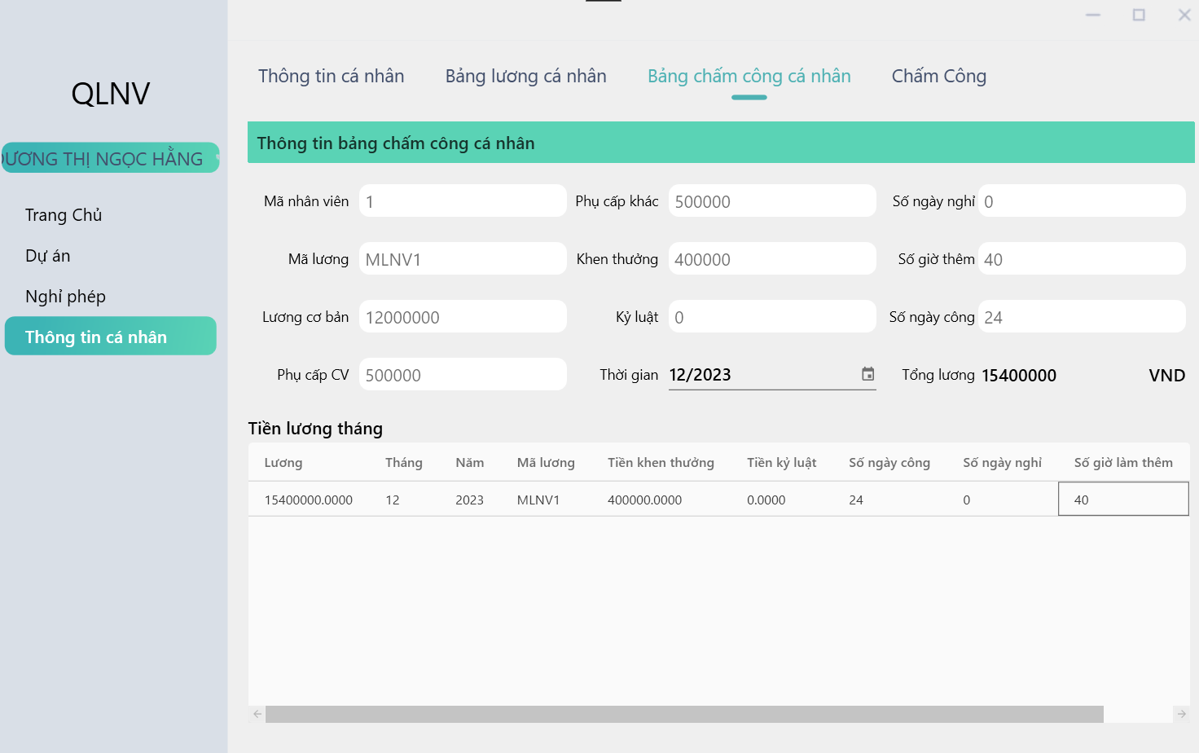

*Figure 4. 23: Personal timesheet screen.*

**+ Timekeeping:**

**-** Users can clock in every day by clicking on the timekeeping button and it will be recorded for easy salary calculation.

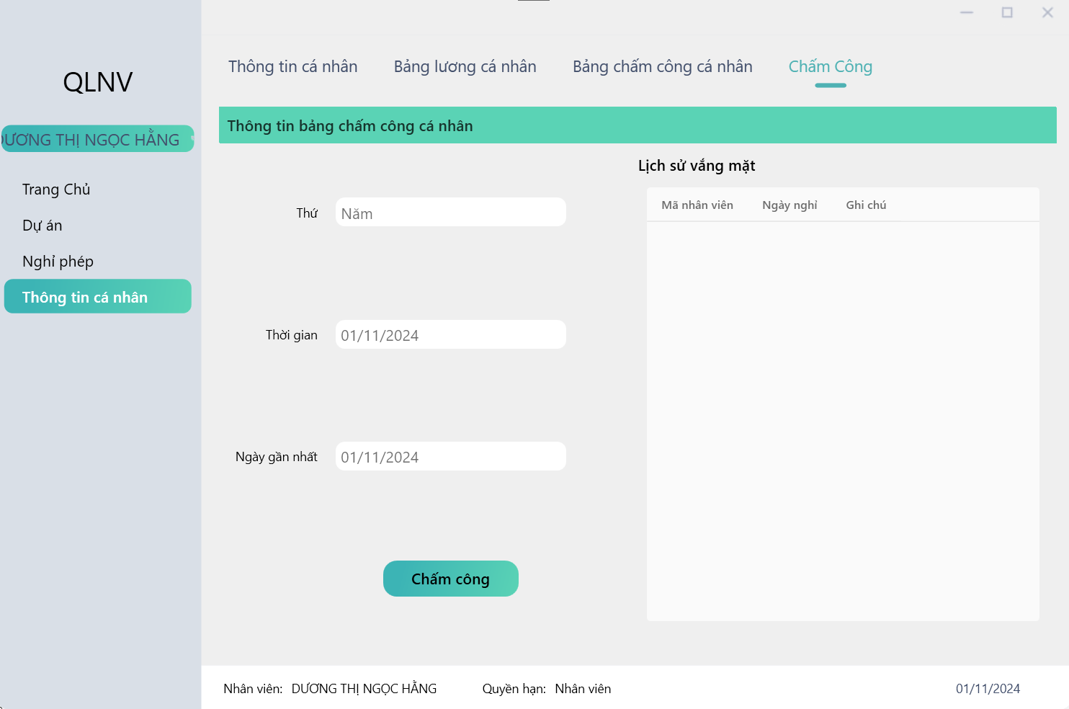

*Figure 4. 24: Timekeeping screen*

**+ Annual leave function.**

The employee logs into the assigned account and creates a leave request, which will be sent to the admin for approval and upon approval, a notification will be sent back to the employee.

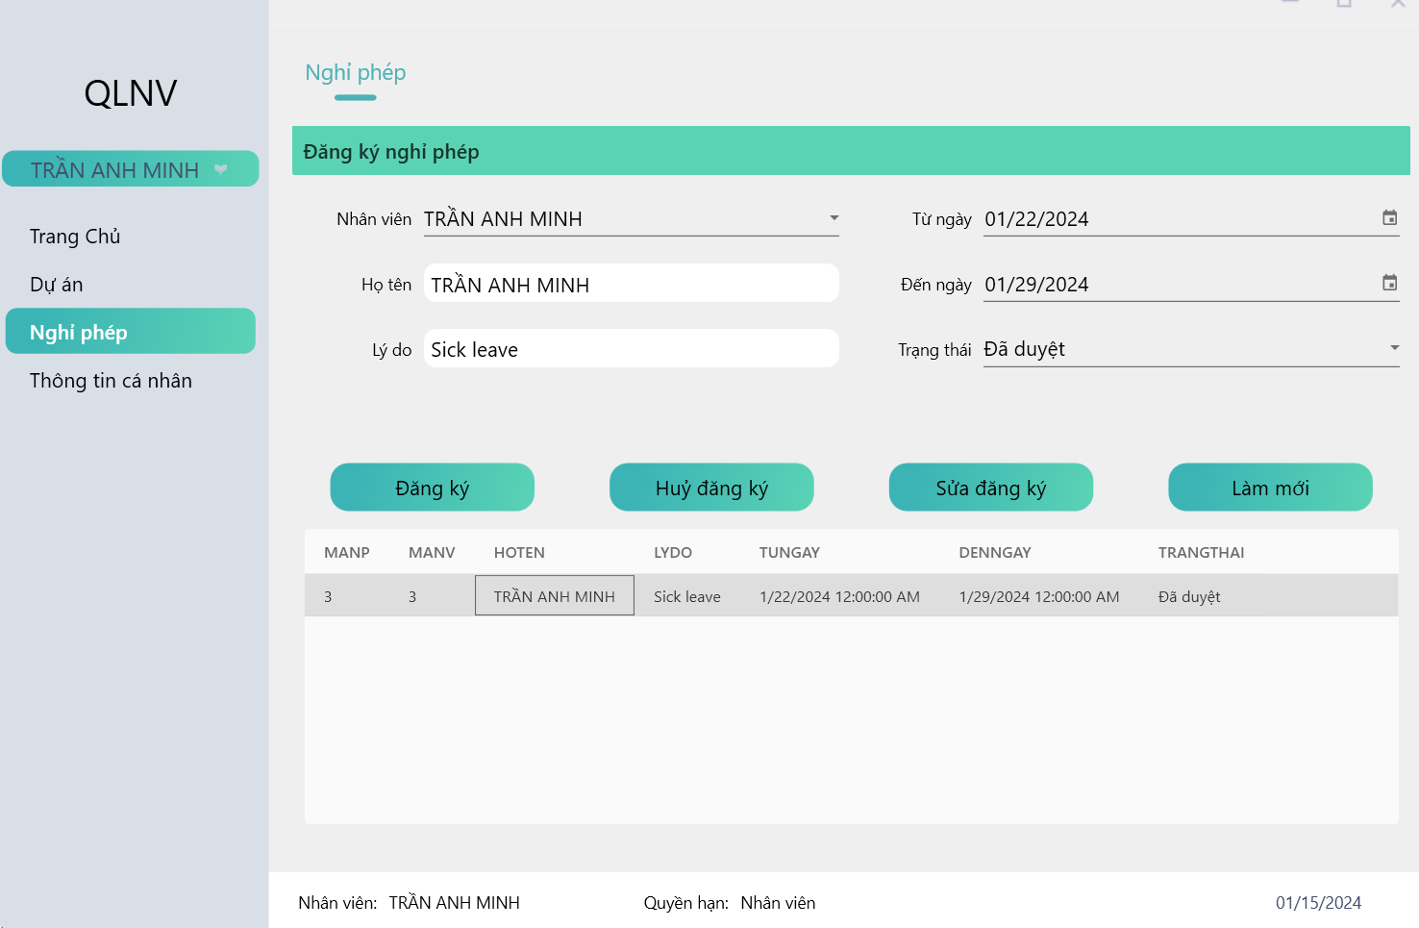

*Figure 4. 25: Annual leave function for user*

**+ Project function.**

The employee logs into the assigned account and see the project if was assigned.

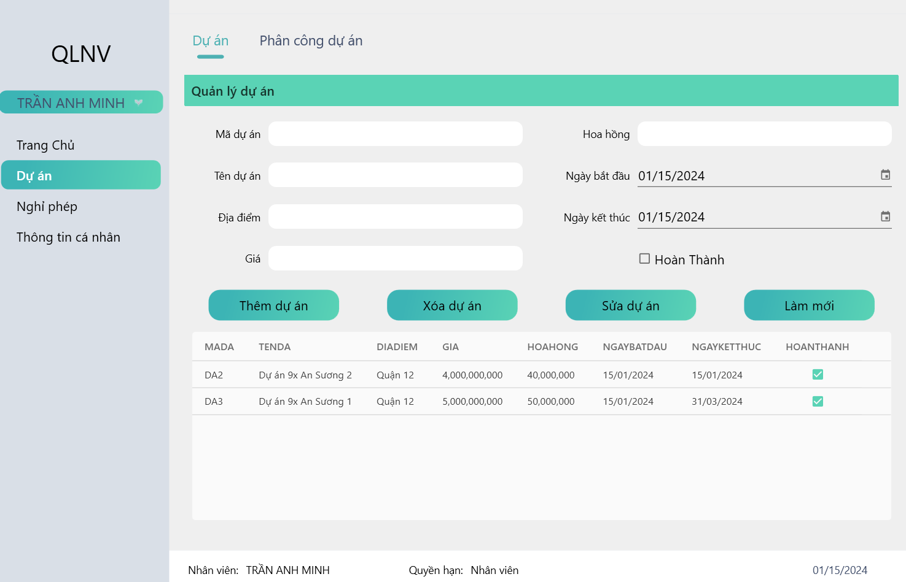

*Figure 4. 26: Project of employees*

## 4.3. Steps to be followed in order for employees.

- Below are some steps that employees often must take when using human resources management software for Hung Thinh real estate company:

### **4.3.1. Steps For ADMIN:**

- **Login**: Open the software and enter admin account (login name and password).

- **View Personal Information:** Check and update personal information such as address, phone number, bank account information, and other related information.

- **Leave and Attendance**: Record leave information, leave applications, and track attendance to ensure accuracy and confirm with company regulations.

- **Search for Human Resources Information**: Use the search function to look up information of colleagues or managers.

- **Profile Management:** Upload and update relevant documents and certificates to personal profile.

- **Check Salary and Benefits**: Check and check information related to salary, bonuses, and other benefits.

- **Statistical reports:** Must report monthly statistics to management on payroll, timesheets, and personnel information.

- **Management process of projects:** Checking process of projects related to bonuses.

### **4.3.2. Steps For STAFF:​**

**- Login:** Open the software and enter personal login information (login name and password).

**- View Personal Information:** Check and update personal information such as address, phone number, and other related information.

**- Leave and Attendance:** Record leave information, leave applications, and daily timekeeping to ensure accuracy and confirm with company regulations.

**- Profile Management:** Upload and update relevant documents and certificates to personal profile.

**- Check Salary and Benefits:** Check and check information related to salary, bonuses, and other benefits.

- **Check process of projects:** Checking process of projects related to bonuses.

# **CHAPTER 5: CONCLUSION**

Through time of research and analysis with the enthusiastic guidance of lecturers at the University of Information Technology in general and Information System in particular. Our team saw the practicality, science and application needs of the system, so we researched and developed human resources management software for Hung Thinh Company, helping to optimize and control employees and salaries in the most reasonable way. However, due to limited time and resources, our project still has some limitations such as:

* The professionalism of the system is not necessarily the most optimal.
* Sometimes problems arise when using the software that we are trying to fix.
* The software's interface is still quite sketchy and incomplete, but we are still trying to develop it to be more eye-catching and suitable for users.

But besides those disadvantages, our project also has many advantage features such as:

* There is a timekeeping system for employees and when employees clock in, it is automatically updated to the system. This makes it easier for managers to monitor and manage employees better.
* Have a reward and discipline system for employees to follow.
* In short, our project has all the necessary parts that a human resources management system should have and can also develop more features in the future.

# **LIST OF REFERENCES**

**[1].** [**Corine Boon**](https://journals.sagepub.com/doi/full/10.1177/0149206318818718#con1)**,**[**Deanne N. Den Hartog**](https://journals.sagepub.com/doi/full/10.1177/0149206318818718#con2)**, and**[**David P. Lepak**](https://journals.sagepub.com/doi/full/10.1177/0149206318818718#con3)**, “***A Systematic Review of Human Resource Management Systems and Their Measurement***”.** [Jan 14, 2019][online]. Available: [A Systematic Review of Human Resource Management Systems and Their Measurement - Corine Boon, Deanne N. Den Hartog, David P. Lepak, 2019 (sagepub.com)](https://journals.sagepub.com/doi/full/10.1177/0149206318818718)

**[2]. Gia Phát Phạm,** “*Demo Hệ Thống Quản Lý Nhân Sự”,* Youtube, [Jun 20, 2021]. [Online]. Available: [(990) Demo Hệ Thống Quản Lý Nhân Sự - YouTube](https://www.youtube.com/watch?v=9yI26VU2Rl0)

**[3].** **Alan Dennis, Babara Haley Wixom, David Tegarden,** “*Systems Analysis and Design: An Object-Oriented Approach with UML, 5th Edition*”, [2015]. [eBook]. Available: [9781118804674 (projanco.com)](http://projanco.com/Library/Systems%20Analysis%20and%20Design-An%20Object-Oriented%20Approach%20with%20UML-2015.pdf)

**[4].** **Naresh i Technologies,** “*.Net Framework tutorial*”, [Aug 18, 2016]. [Online]. Available: [Introduction to .NET | C#.NET Tutorial | Mr. Bangar Raju - YouTube](https://www.youtube.com/watch?v=0u9k-kOR3KE&list=PLVlQHNRLflP-jc5Fbhfdhzv52AWYq836j)

**[5]. L.B.P. da Silva a, R. Soltovski a, J. Pontes**“*Human resources management 4.0: Literature review and trends*”, [March 30 2022]. [Online]. Available: [Human resources management 4.0: Literature review and trends - ScienceDirect](https://www.sciencedirect.com/science/article/abs/pii/S0360835222001814)

**[6].** “*Giới thiệu về công ty Hưng Thịnh*” [Online]. Available: [GIỚI THIỆU VỀ CÔNG TY TẬP ĐOÀN HƯNG THỊNH (HƯNG THỊNH CORP) (hungthinhbds.net)](https://hungthinhbds.net/gioi-thieu-ve-cong-ty-hung-thinh)

**[7].***“Chu kỳ phát triển phần mềm”* [Online]. Available:<https://vntesters.com/chu-ky-phat-trien-phan-mem-sdlc/>

**[8].** *“Các lĩnh vực hoạt động của công ty BĐS Hưng Thịnh”* [Online] Available:https://hungthinhcorp.com.vn/linhvuchoatdong.html

# **APPENDIX: SURVEYS FORM OF REAL ESTATE COMPANY**

- The purpose of this survey is to collect basic company information such as working hours, shifts or basic salary of employees.

- Because we are only a small and medium company, the number of surveys is limited to about 15 surveys.

- From the conclusions we have gathered, we have analyzed, researched and developed the software to be the most suitable and friendly for the company.

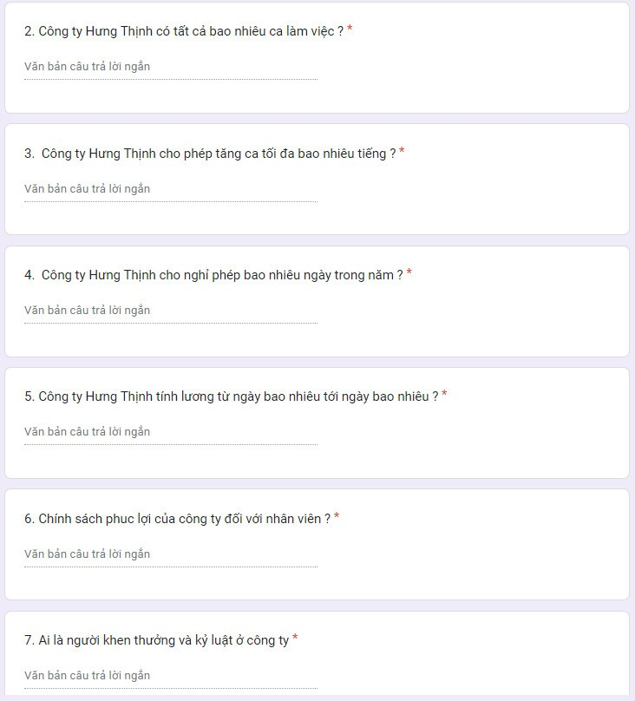

Figure 1: Employee survey form

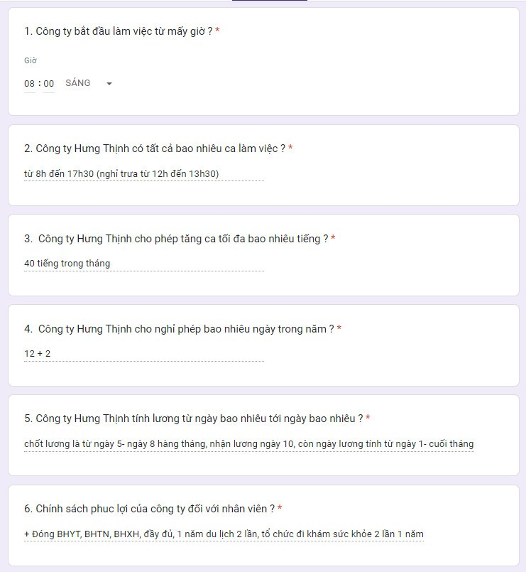

Figure 2: The survey form has been filled out.

Thanks for your reading.